Chapter 5
USB Data Flow Model

This chapter presents information about how data is moved across the USB that affects all implementers. The information presented is at a level above the signaling and protocol definitions of the system. Chapter 7, Electrical and Chapter 8, Protocol Layer should be consulted for more details about their respective parts of the USB system. This chapter provides framework information that is further expanded in Chapter 9, USB Device Framework, Chapter 10, USB Host: Hardware and Software, and Chapter 11, Hub Specification. This chapter should be read by all implementers to understand key concepts of the USB.

Implementer Viewpoints
The USB provides communication services between a host and attached USB devices. However, the simple view an end user sees of attaching one or more USB devices to a host, as in Figure 5-1, is in fact a little more complicated to implement than as indicated by the figure. Different views of the system are required to explain specific USB requirements from the perspective of different implementers. Several important concepts and features must be supported to provide the end user with the reliable operation demanded from today’s personal computers. USB is presented in a layered fashion to ease explanation and allow implementers of particular USB products to focus on the details related to their product.
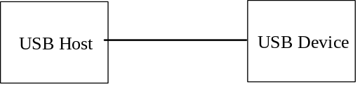
Figure 5-1. Simple USB Host/Device View
Figure 5-2 shows a deeper overview of USB identifying the different layers of the system that will be described in more detail in the remainder of the specification. In particular, there are four focus implementation areas:
- USB Physical Device - A piece of hardware on the end of a USB cable that performs some useful end user function.
- Client Software - Software that executes on the host corresponding to a USB device. This client software is typically supplied with the operating system or provided along with the USB device.
- USB System Software - Software that supports USB in a particular operating system. Typically supplied with the operating system independently of particular USB devices or client software.
- USB Host Controller (Host Side Bus Interface) - The hardware and software that allows USB devices to be attached to a host.
There are shared rights and responsibilities between the four USB system components. The remainder of this specification describes the details required to support robust, reliable communication flows between a function and its client.
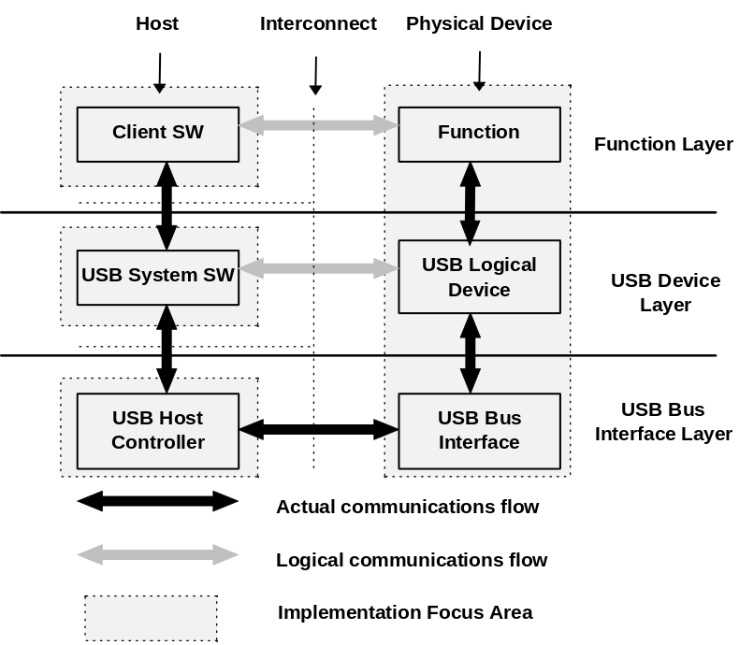
Figure 5-2. USB Implementation Areas
As shown in Figure 5-2, the simple connection of a host to a device requires interaction between a number of layers and entities. The USB Bus Interface layer provides physical/signaling/packet connectivity between the host and a device. The USB Device Layer is the view the USB System software has for performing generic USB operations with a device. The Function Layer provides additional capabilities to the host via an appropriate matched client software layer. The USB Device and Function layers each have a view of logical communication within their layer that actually uses the USB Bus Interface Layer to accomplish data transfer.
The physical view of USB communication as described in Chapters 6, 7, and 8 is related to the logical communication view presented in Chapters 9 and 10. This chapter describes those key concepts that affect USB implementers and should be read by all before proceeding to the remainder of the specification to find those details most relevant to their product.
To describe and manage USB communication, the following concepts are important:
- Bus Topology: Section 5.2 presents the primary physical and logical components of USB and how they interrelate.
- Communication Flow Models: Sections 5.3 through 5.8 describe how communication flows between the host and devices through the USB and defines the four USB transfer types.
- Bus Access Management: Section 5.9 describes how bus access is managed within the host to support a broad range of communication flows by USB devices.
- Special Consideration for Isochronous Transfers: Section 5.10 presents features of USB specific to devices requiring isochronous data transfers. Device implementers for non-isochronous devices will not need to read Section 5.10.

Bus Topology
There are four main parts to USB topology:
- Host and Devices: The primary components of a USB system.
- Physical Topology: How USB elements are connected.
- Logical Topology: The roles and responsibilities of the various USB elements and how the USB appears from the perspective of the host and a device.
- Client software to function relationships: How client software and its related function interfaces on a USB device view each other.

USB Host
The host’s logical composition as shown in Figure 5-3 is:
- The USB host controller
- The aggregate USB system software (USB driver, host controller driver, and host software)
- The client
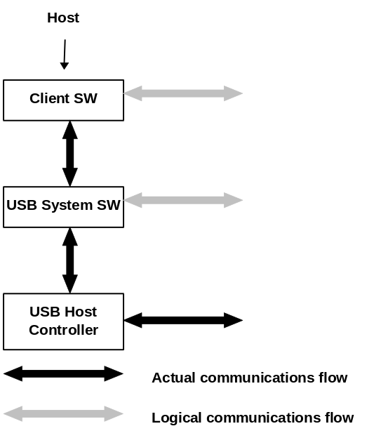
Figure 5-3. Host Composition
The USB host occupies a unique position as the coordinating entity for the USB. In addition to its special physical position, the host has specific responsibilities with regard to the USB and its attached devices. The host controls all access to the USB. A USB device only gains access to the bus by being granted access by the host. The host is also responsible for monitoring the topology of the USB.
For a complete discussion of the host and its duties, refer to Chapter 10, USB Host: Software and Hardware.

USB Devices
A USB physical device’s logical composition as shown in Figure 5-4 is:
- USB bus interface
- USB logical device
- Function
USB physical devices provide additional functionality to the host. The types of functionality provided by USB devices vary widely. However, all USB logical devices present the same basic interface to the host. This allows the host to manage the USB-relevant aspects of different USB devices in the same manner.
To assist the host in identifying and configuring USB devices, each device carries and reports configuration related information. Some of the information reported is common among all logical devices. Other information is specific to the functionality provided by the device. The detailed format of this information varies depending on the device class of the device.
For a complete discussion of USB devices, refer to Chapter 9, USB Device Framework.
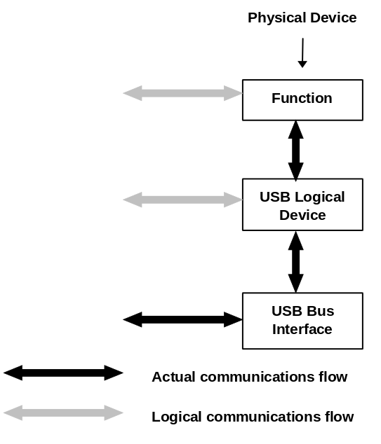
Figure 5-4. Physical Device Composition

Physical Bus Topology
Devices on the USB are physically connected to the host via a tiered star topology, as illustrated in
Figure 5-5. USB attachment points are provided by a special class of USB device known as a hub. The additional attachment points provided by a hub are called ports. A host includes an embedded hub called the root hub. The host provides one or more attachment points via the root hub. USB devices which provide additional functionality to the host are known as functions. To prevent circular attachments, a tiered ordering is imposed on the star topology of the USB. This results in the tree-like configuration illustrated in Figure 5-5.
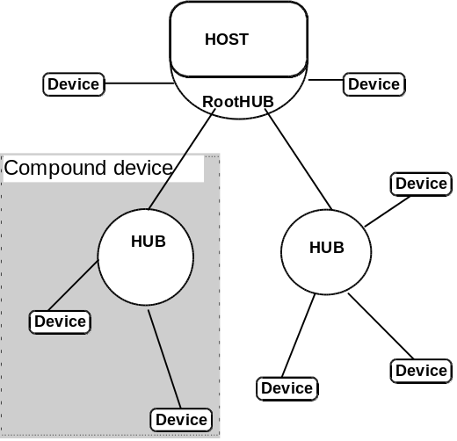
Figure 5-5. USB Physical Bus Topology
Multiple functions may be packaged together in what appears to be a single physical device. For example, a keyboard and a trackball might be combined in a single package. Inside the package, the individual functions are permanently attached to a hub and it is the internal hub that is connected to the USB. When multiple functions are combined with a hub in a single package, they are referred to as a compound device. From the host’s perspective, a compound device is the same as a separate hub with multiple functions attached. Figure 5-5 also illustrates a compound device.

Logical Bus Topology
While devices physically attach to the USB in a tiered, star topology, the host communicates with each logical device as if it were directly connected to the root port. This creates the logical view illustrated in Figure 5-6 that corresponds to the physical topology shown in Figure 5-5. Hubs are logical devices also, but are not shown in Figure 5-6 to simplify the picture. Even though most host/logical device activities use this logical perspective, the host maintains an awareness of physical topology to support processing the removal of hubs. When a hub is removed, all of the devices attached to the hub must be removed from the host’s view of the logical topology. A more complete discussion of hubs can be found in Chapter 11, Hub Specification.
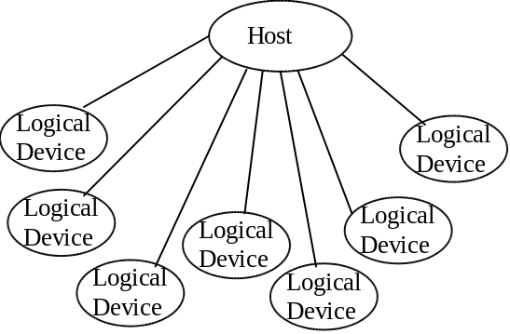
Figure 5-6. USB Logical Bus Topology

Client Software to Function Relationship
Even though the physical and logical topology of the USB reflects the shared nature of the bus, client software(CSw) manipulating a USB function interface is presented with the view that it deals only with its interface(s) of interest. Client software for USB functions must use USB software programming interfaces to manipulate their functions as opposed to directly manipulating their functions via memory or I/O accesses as with other buses (e.g., PCI, EISA, PCMCIA, etc.). During operation, client software should be independent of other devices that may be connected to USB. This allows the designer of the device and client software to focus on the hardware/software interaction design details. Figure 5-7 illustrates a device designer’s perspective of the relationships of client software and USB functions with respect to the USB logical topology of Figure 5-6.
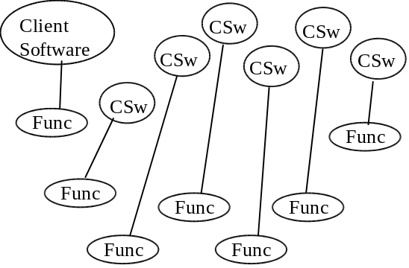
Figure 5-7. Client Software to Function Relationships

USB Communication Flow
USB provides a communication service between software on the host and its USB function. Functions can have different communication flow requirements for different client to function interactions. USB provides better overall bus utilization by allowing the separation of the different communication flows to a USB function. Each communication flow makes use of some bus access to accomplish communication between client and function. Each communication flow is terminated at an endpoint on a device. Device endpoints are used to identify aspects of each communication flow.
The diagram in Figure 5-8 shows a more detailed view of Figure 5-2. The complete definition of the actual communication flows of Figure 5-2 supports the logical device and function layer communication flows. These actual communication flows cross several interface boundaries. Chapters 6, 7, and 8 describe the mechanical, electrical, and protocol interface definitions of the USB “wire.” Chapter 9 describes the USB device programming interface that allows a USB device to be manipulated from the host side of the wire. Chapter 10 describes two host side software interfaces:
- Host Controller Driver (HCD) - the software interface between the USB host controller and USB system software. This interface allows a range of host controller implementations without requiring all host software to be dependent on any particular implementation. One USB Driver can support different host controllers without requiring specific knowledge of a host controller implementation. A host controller implementer provides an HCD implementation that supports the host controller.
- USB Driver (USBD) - the interface between USB system software and the client software. This interface provides clients with convenient functions for manipulating USB devices.
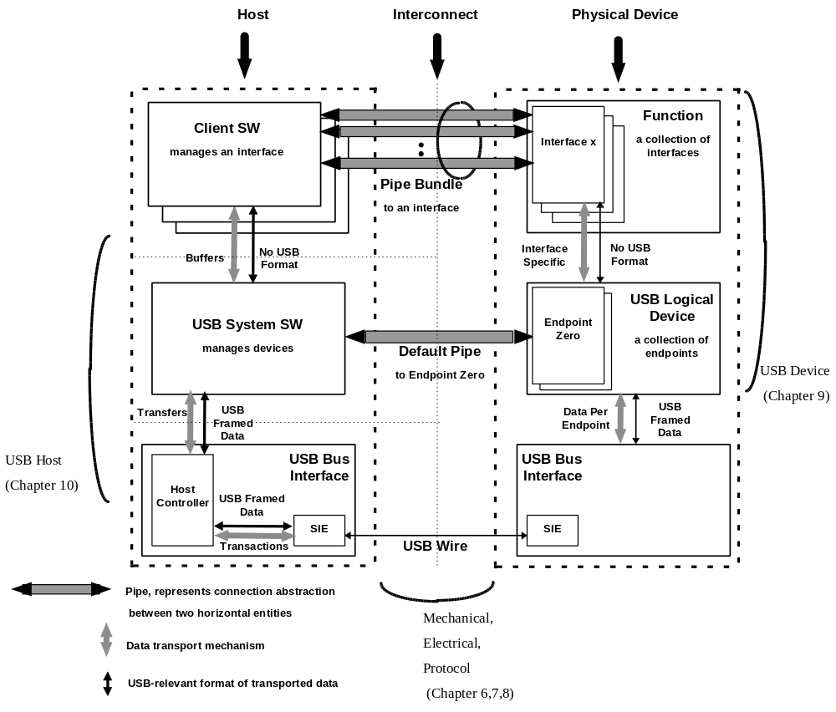
Figure 5-8. USB Host/Device Detailed View
A USB logical device appears to the USB system as a collection of endpoints. Endpoints are grouped into endpoint sets which implement an Interface. Interfaces are views to the function. System software manages the device using the Default Pipe (associated with Endpoint 0). Client software manages an Interface using pipe bundles (associated with an Endpoint Set). Client software requests that data be moved across the USB between a buffer on the host and an endpoint on the USB device. The host controller (or USB device depending on transfer direction) packetizes the data to move it over the USB. The host controller also coordinates when bus access is used to move the packet of data over the USB.
Figure 5-9 illustrates how communication flows are carried over pipes between endpoints and host side memory buffers. The following sections describe endpoints, pipes, and communication flows in more detail.
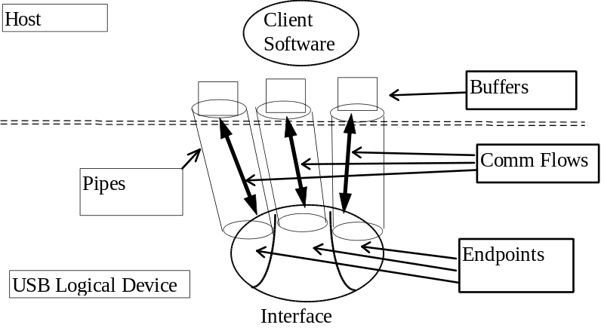
Figure 5-9. USB Communication Flow
Software on the host communicates with a logical device via a set of communication flows. The set of communication flows are selected by the device software/hardware designer(s) to efficiently match the communication requirements of the device to the transfer characteristics provided by USB.

Device Endpoints
An endpoint is a uniquely identifiable portion of a USB device that is the terminus of a communication flow between the host and device. Each USB logical device is composed of a collection of independently operating endpoints. Software may only communicate with a USB device via one or more endpoints. Each logical device has a unique address assigned by the system at device attachment time. Each endpoint on a device has a device (design time) determined unique identifier, the endpoint number. The combination of the device address and the endpoint number allows each endpoint to be uniquely referenced.
An endpoint has characteristics that determine the type of transfer service required between the endpoint and the client software. Endpoints describe themselves by:
- Their bus access frequency/latency requirements
- Their bandwidth requirements
- Their endpoint number
- The error handling behavior requirements
- Maximum packet size that the endpoint is capable of sending or receiving
- The transfer type for the endpoint (refer to Section 5.4 for details)
- For bulk and isochronous transfer types, the direction data is transferred between the endpoint and the host
Endpoints are in an unknown state before being configured. Endpoints must not be accessed by the host before being configured.

Endpoint 0 Requirements
All USB devices are required to have an endpoint with endpoint number 0 that is used to initialize and generically manipulate the logical device (e.g., to configure the logical device). Endpoint 0 provides access to the device’s configuration information and allows generic USB status and control access. Endpoint 0 supports control transfers as defined in Section 5.5. Endpoint 0 is always configured once a device is attached and powered.

Non-endpoint 0 Requirements
Functions can have additional endpoints as required for their implementation. Low speed functions are limited to two optional endpoints beyond the required Endpoint 0. Full speed devices can have additional endpoints only limited by the protocol definition; i.e., a maximum of 16 input endpoints and 16 output endpoints.
An endpoint cannot be used until it is configured. Endpoints, besides Endpoint 0, are configured as a normal part of the device configuration process (refer to Chapter 9).

Pipes
A USB pipe is an association between an endpoint on a device and software on the host. Pipes represent the ability to move data between software on the host via a memory buffer and an endpoint on a device. There are two different, mutually exclusive, pipe communication modes:
- Stream. Data moving through a pipe has no USB defined structure.
- Message. Data moving through a pipe has some USB defined structure.
USB does not interpret the content of data it delivers through a pipe. Even though a message pipe requires that data be structured according to USB definitions, the content of the data is not interpreted by USB.
Additionally, pipes have associated with them:
- A claim on USB bus access and bandwidth usage.
- A transfer type.
- The associated endpoint’s characteristics such as directionality and maximum data payload sizes. The data payload is the data that is carried in the data field of a data packet within a bus transaction (as defined in Chapter 8).
Pipes come into existence when a USB device is configured. Since Endpoint 0 is always configured once a device is powered, there is always a pipe for Endpoint 0. This pipe is called the Default Pipe. This pipe is used by system software to determine device identification and configuration requirements, and to configure the device. The Default Pipe can also be used by device specific software after the device is configured. USB system software retains “ownership” of the Default Pipe and mediates use of the pipe by other client software.
A software client normally requests data transfers via I/O Request Packets (IRPs) to a pipe and then either waits or is notified when they are completed. Details about IRPs are defined in an operating system specific manner. This specification uses the term to simply refer to an identifiable request by a software client to move data between itself (on the host) and an endpoint of a device in an appropriate direction. A software client can cause a pipe to return all outstanding IRPs if it desires. The software client is notified that an IRP has completed when the bus transactions associated with it have completed either successfully or due to errors.
If there are no IRPs pending or in progress for a pipe, the pipe is idle and the host controller will take no action with regard to the pipe; i.e., the endpoint for such a pipe will not see any bus transactions directed to it. The only time bus activity is present for a pipe is when IRPs are pending for that pipe.
If a non-isochronous pipe encounters a STALL condition (refer to Chapter 8) or three bus errors are encountered on any packet of an IRP, the IRP is aborted/retired, all outstanding IRPs are also retired, and no further IRPs are accepted until the software client recovers from the condition (in an implementation dependent way) and acknowledges the STALL or error condition via a USBD call. An appropriate status informs the software client of the specific IRP result for error versus STALL (refer to Chapter 10). Isochronous pipe behavior is described in Section 5.6.
An IRP may require multiple data payloads to move the client data over the bus. The data payloads for such a multiple data payload IRP are expected to be maximum packet sized until the last data payload that contains the remainder of the overall IRP. See each transfer type specific description for more details. For such an IRP, short packets (i.e., less than maximum sized data payloads) on input that do not completely fill an IRP data buffer can have one of two possible meanings depending upon the expectations of a client.
- A client can expect a variable sized amount of data in an IRP. In this case, a short packet that does not fill an IRP data buffer can be used simply as an inband delimiter to indicate “end of unit of data.” The IRP should be retired without error and the host controller should advance to the next IRP.
- A client can expect a specific sized amount of data. In this case, a short packet that does not fill an IRP data buffer is an indication of an error. The IRP should be retired, the pipe should be stalled, and any pending IRPs associated with the pipe should also be retired.
Since the host controller must behave differently in the two cases and cannot know on its own which way to behave for a given IRP, it is possible to indicate per IRP which behavior the client desires.
An endpoint can inform the host that it is busy by responding with a NAK. NAKs are not used as a retire condition for returning an IRP to a software client. Any number of NAKs can be encountered during the processing of a given IRP. A NAK response to a transaction does not constitute an error and is not counted as one of the three errors described above.

Stream Pipes
Stream pipes deliver data in the data packet portion of bus transactions with no USB required structure on the data content. Data flows in at one end of a stream pipe and out the other end in the same order. Stream pipes are always unidirectional in their communication flow.
Data flowing through a stream pipe is expected to interact from what USB believes is a single client. USB System software is not required to provide synchronization between multiple clients that may be using the same stream pipe. Data presented to a stream pipe is moved through the pipe in sequential order: first-in, first-out.
A stream pipe to a device is bound to a single device endpoint number in the appropriate direction (i.e., corresponding to an IN or OUT token as defined by the protocol layer). The device endpoint number for the opposite direction can be used for some other stream pipe to the device.
Stream pipes support bulk, isochronous, and interrupt transfer types explained below.

Message Pipes
Message pipes interact with the endpoint in a different manner than stream pipes. First, a request is sent to the USB device from the host. This request is followed by data transfer(s) in the appropriate direction. Finally, a status stage follows at some later time by a response from the endpoint. In order to accommodate the request/data/status paradigm, message pipes impose a structure on the communication flow which allows commands to be reliably identified and communicated. Message pipes allow communication flow in both directions although the communication flow may be predominately one way. The pipe for Endpoint 0, the Default Pipe, is always a message pipe.
USB system software ensures that multiple requests are not sent to an endpoint concurrently. An endpoint is only required to service a single message request at a time per endpoint. Multiple software clients on the host can make requests via the Default Pipe, but they are sent to the endpoint in a first-in, first-out order. An endpoint can control the flow of information during the data and status stages based on its ability to respond to the host transactions (refer to Chapter 8 for more details).
An endpoint will not normally be sent the next message from the host until the current message’s processing at the endpoint has been completed. However, there are error conditions whereby a message transfer can be aborted by the host and the endpoint can be sent a new message transfer prematurely (from its perspective). From the perspective of the software manipulating a message pipe, an error on some part of an IRP retires the current IRP and all queued IRPs. The software client that requested the IRP is notified of the IRP completion with an appropriate error indication.
A message pipe to a device requires a single device endpoint number in both directions (IN and OUT tokens). USB does not allow a message pipe to be associated with different endpoint numbers for each direction.
Message pipes support the control transfer type explained below.

Transfer Types
USB transports data through a pipe between a memory buffer associated with a software client on the host and an endpoint on the USB device. Data transported by message pipes is carried in a USB defined structure, but USB allows device specific structured data to be transported within the USB defined message data payload. USB also defines that data moved over the bus is packetized for any pipe (stream or message), but ultimately the formatting and interpretation of the data transported in the data payload of a bus transaction is the responsibility of the client software and function using the pipe. However, USB provides different transfer types that are optimized to more closely match the service requirements of the client software and function using the pipe. An IRP uses one or more bus transactions to move information between a software client and its function.
Each transfer type determines various characteristics of the communication flow including:
- Data format imposed by USB
- Direction of communication flow
- Packet size constraints
- Bus access constraints
- Required data sequences
The designers of a USB device choose the capabilities for the device’s endpoints. When a pipe is established for an endpoint, most of the pipe’s transfer characteristics are determined and remain fixed for the lifetime of the pipe. Transfer characteristics that can be modified are described for each transfer type.
USB defines four transfer types:
- Control Transfers - Bursty, non-periodic, host software initiated request/response communication typically used for command/status operations.
- Isochronous Transfers - Periodic, continuous communication between host and device typically used for time relevant information. This transfer type also preserves the concept of time encapsulated in the data. This does not imply, however, that the delivery needs of such data is always time-critical.
- Interrupt Transfers - Small data, non-periodic, low frequency, bounded latency, device initiated communication typically used to notify the host of device service needs.
- Bulk Transfers - Non-periodic, large bursty communication typically used for data that can use any available bandwidth and also be delayed until bandwidth is available.
Each transfer type is described in detail in the following four major sections. The data for any IRP is carried by the data field of the data packet as described in Section 8.4.3. Chapter 8 also describes details of the protocol that are affected by use of each particular transfer type.

Control Transfers
Control transfers allow access to different parts of a device. Control transfers are intended to support configuration/command/status type communication flows between client software and its function. A control transfer is composed of a setup bus transaction moving request information from host to function, zero or more data transactions sending data in the direction indicated by the setup transaction, and a status transaction returning status information from function to host. The status transaction returns “success” when the endpoint has successfully completed processing the requested operation. Section 8.5.2 describes the details of what packets, bus transactions, and transaction sequences are used to accomplish a control transfer. Chapter 9 describes the details of the defined USB command codes.
Each USB device is required to implement Endpoint 0 with a control transfer type. This endpoint is used by the USB system software as a control pipe. Control pipes provide access to the USB device’s configuration, status, and control information. A function can provide endpoints for additional control pipes for its own implementation needs.
The USB device framework (refer to Chapter 9) defines standard, device class, or vendor specific requests that can be used to manipulate a device’s state. Descriptors are also defined that can be used to contain different information on the device. Control transfers provide the transport mechanism to access device descriptors and make requests of a device to manipulate its behavior.
Control transfers are only carried through message pipes. Consequently, data flows using control transfers must adhere to USB data structure definitions as described in Section 5.5.1.
USB subsystem will make a “best effort” to support delivery of control transfers between the host and devices. A function and its client software cannot request specific bus access frequency or bandwidth for control transfers. USB system software may restrict the bus access and bandwidth that a device may desire for control transfers. These restrictions are defined in Section 5.5.3 and Section 5.5.4.

Data Format
The setup packet has a USB defined structure that accommodates the minimum set of commands required to enable communication between the host and a device. The structure definition allows vendor specific extensions for device specific commands. The data transactions following setup have no USB defined structure. The status transaction also has a USB defined structure. Specific control transfer setup/data definitions are described in Section 8.5.2 and Chapter 9.

Direction
Control transfers are supported via bi-directional communication flow over message pipes.

Packet Size Constraints
An endpoint for control transfers specifies the maximum data payload size that the endpoint can accept from or transmit to the bus. USB defines the allowable maximum control data payload sizes for full speed devices to be only 8, 16, 32, or 64 bytes. Low speed devices are limited to only an 8 byte maximum data payload size. This maximum applies to the data payloads of the data packets following a setup; i.e., the size specified is for the data field of the packet as defined in Chapter 8, not including other protocol required information. A setup packet is always 8 bytes. A control endpoint always uses its MaxPacketSize for data payloads.
All control endpoints are required to support a control data payload maximum size of 8 bytes after reset. An endpoint can be designed to support a larger maximum data payload size. Such an endpoint reports in its configuration information the value for its maximum data payload size. USB does not require that data payloads transmitted be exactly the maximum size; i.e., if a data payload is less than the maximum, it does not need to be padded to the maximum size.
All host controllers are required to have support for 8, 16, 32, and 64 byte maximum data payload sizes for full speed control endpoints and only 8 byte maximum data payload sizes for low speed control endpoints. No host controller is required to support larger or smaller maximum data payload sizes.
During configuration, USB system software reads the endpoint’s maximum data payload size and ensures that no data payload will be sent to the endpoint that is larger than the supported size. The host will always use a maximum data payload size of at least 8 bytes.
An endpoint must always transmit data payloads with a data field less than or equal to the endpoint’s MaxPacketSize (refer to Chapter 9). When a control transfer involves more data than can fit in one data payload of the currently established maximum size, all data payloads are required to be maximum sized except for the last data payload which will contain the remaining data. If an endpoint wants to transmit less data than expected by the client software, a premature, less than maximum sized data payload will be received by the host controller. This premature, less than maximum sized data payload causes the host controller to advance to the status transaction instead of continuing on with another data transaction or else stall the pipe as was outlined in Section 5.3.2. If a data payload is received that is larger than that expected, the IRP for the control transfer will be aborted/retired and the pipe will stall future IRPs until the condition is corrected and acknowledged.

Bus Access Constraints
Control transfers can be used by full speed and low speed USB devices.
An endpoint has no way to indicate a desired bus access frequency for a control pipe. USB balances the bus access requirements of all control pipes and the specific IRPs that are pending to provide “best effort” delivery of data between client software and functions.
USB requires that part of each frame be reserved to be available for use by control transfers as follows:
- If the control transfers that are attempted (in an implementation dependent fashion) consume less than 10% of the frame time, the remaining time can be used to support bulk transfers (refer to Section 5.8).
- A control transfer that has been attempted and needs to be retried can be retried in the current or a future frame; i.e., it is not required to be retried in the same frame.
- If there are more control transfers than reserved time, but there is additional frame time that is not being used for isochronous or interrupt transfers, a host controller may move additional control transfers as they are available.
- If there are too many pending control transfers than available frame time, control transfers are selected to be moved over the bus as appropriate.
- If there are control transfers pending for multiple endpoints, control transfers for the different endpoints are selected according to a fair access policy that is host controller implementation dependent.
- A transaction of a control transfer that is frequently being retried should not be expected to consume an unfair share of the frame time.
These requirements allow control transfers between host and devices to be regularly moved over the bus with “best effort.”
All control transfers pending in a system contend for the same available bus time. Because of this, the bus time made available for control transfers to a particular endpoint can be varied by USB system software at its discretion. An endpoint and its client software cannot assume a specific rate of service for control transfers. Bus time made available to a software client and its endpoint can be changed as other devices are inserted into and removed from the system or also as control transfers are requested for other device endpoints.
The bus frequency and frame timing limit the maximum number of successful control transfers within a frame for any USB system to less than 29 full speed 8 byte data payloads or less than four low speed 8 byte data payloads. Table 5-1 lists information about different sized full speed control transfers and the maximum number of transfers possible in a frame. This table was generated assuming zero length status data stage transaction and one data stage transaction. The table illustrates the possible power of two data payloads less than or equal to the allowable maximum data payload sizes.
Table 5-1. Full Speed Control Transfer Limits
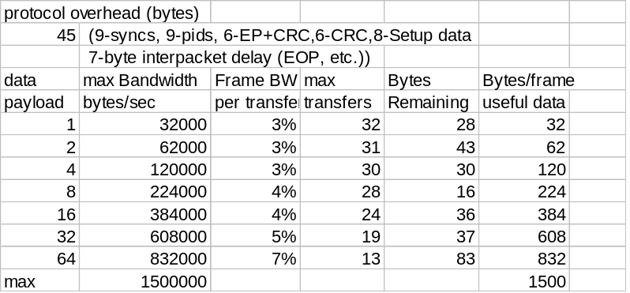
The 10% frame reservation for control transfers means that in a system with bus time fully allocated, all full speed control transfers in the system contend for a nominal three control transfers per frame. Since the USB subsystem uses control transfers for configuration purposes in addition to whatever other control transfers other client software may be requesting, a given software client and its function should not expect to be able to make use of this full bandwidth for its own control purposes. Host controllers are also free to determine how the individual bus transactions for specific control transfers are moved over the bus within and across frames. An endpoint could see all bus transactions for a control transfer within the same frame or spread across several discontiguous frames. Finally, a host controller, for various implementation reasons, may not be able to provide the theoretical maximum number of control transfers per frame.
Both full speed and low speed control transfers contend for the same available frame time. Low speed control transfers simply take longer to transfer. Table 5-2 lists information about different sized low speed packets and the maximum number of packets possible in a frame. Also for both speeds, since a control transfer is composed of several packets, the packets can be spread over several frames to spread the bus time required across several frames.
Table 5-2. Low Speed Control Transfer Limits
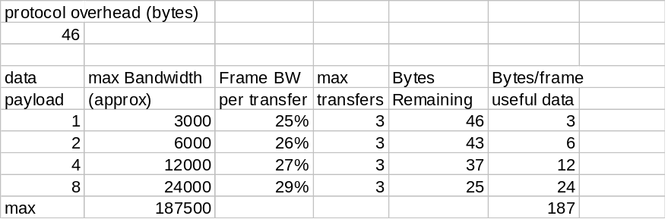

Data Sequences
Control transfers require that a setup bus transaction be sent from the host to a device to describe the type of control access that the device should perform. The setup transaction is followed by zero or more control data transactions that carry the specific information for the requested access. Finally, a status transaction completes the control transfer and allows the endpoint to return the status of the control transfer to the client software. After the status transaction for a control transfer is completed, the host can advance to the next control transfer for the endpoint. As described in Section 5.5.4, this next control transfer will be moved over the bus at some host controller implementation defined time in the future.
The endpoint can be busy for a device specific numbers of frames during the data and status transactions of the control transfer. During these times when the endpoint indicates it is busy (refer to Chapter 8 and Chapter 9 for details), the host will retry the transaction at a later time.
If a setup transaction is received by an endpoint before a previously initiated control transfer is completed, the device must abort the current transfer/operation and handle the new control setup transaction. A setup transaction should not normally be sent before the completion of a previous control transfer. However, if a transfer is aborted, for example, due to errors on the bus, the host can send the next setup transaction prematurely from the endpoint’s perspective.
After a STALL condition is encountered or an error is detected by the host, a control endpoint is allowed to recover by accepting the next setup PID; i.e., recovery actions via some other pipe are not required for control endpoints, but may be required by implementation for some. For the Default Pipe (Endpoint 0), a device reset (by USBD) will ultimately be required to clear the STALL or error condition if the next setup PID is not accepted.
USB provides robust error detection, recovery/retransmission for errors that occur during control transfers. Transmitters and receivers can remain synchronized with regard to where they are in a control transfer and recover with minimum effort. Retransmission of data and status packets can be detected by a receiver via data retry indicators in the packet. A transmitter can reliably determine that its corresponding receiver has successfully accepted a transmitted packet by information returned in a handshake to the packet. The protocol allows for distinguishing a retransmitted packet from its original packet except for a control setup packet. Setup packets may be retransmitted due to a transmission error; however, setup packets cannot indicate that a packet is an original or a retried transmission.

Isochronous Transfers
In non-USB environments, isochronous transfers have the general implication of constant-rate, error-tolerant transfers. In the USB environment, requesting an isochronous transfer type provides the requester with the following:
- Guaranteed access to USB bandwidth with bounded latency
- As long as data is provided to the pipe, a constant data rate through the pipe is guaranteed
- In the case of a delivery failure due to error, no retrying of the attempt to deliver the data
While the USB isochronous transfer type is designed to support isochronous sources and destinations, it is not required that software using this transfer type actually be isochronous in order to use the transfer type. Section 5.10 presents more detail on special considerations for handling isochronous data on USB.

Data Format
USB imposes no data content structure on communication flows for isochronous pipes.

Direction
An isochronous pipe is a stream pipe and is, therefore, always unidirectional. An endpoint description identifies whether a given isochronous pipe’s communication flow is into or out of the host. If a device requires bi-directional isochronous communication flow, two isochronous pipes must be used, one in each direction.

Packet Size Constraints
An endpoint in a given configuration for an isochronous pipe specifies the maximum size data payload that it can transmit/receive. USB system software uses this information during configuration to ensure that there is sufficient bus time to accommodate this maximum data payload in each frame. If there is sufficient bus time for the maximum data payload, the configuration is established; if not, the configuration is not established. USB system software does not adjust the maximum data payload size for an isochronous pipe as was the case for a control pipe. An isochronous pipe can simply either be supported or not supported in a given USB subsystem configuration.
USB limits the maximum data payload size to 1023 bytes for each isochronous pipe. Table 5-3 lists information about different sized isochronous transactions and the maximum number of transactions possible in a frame.
Table 5-3. Isochronous Transaction Limits
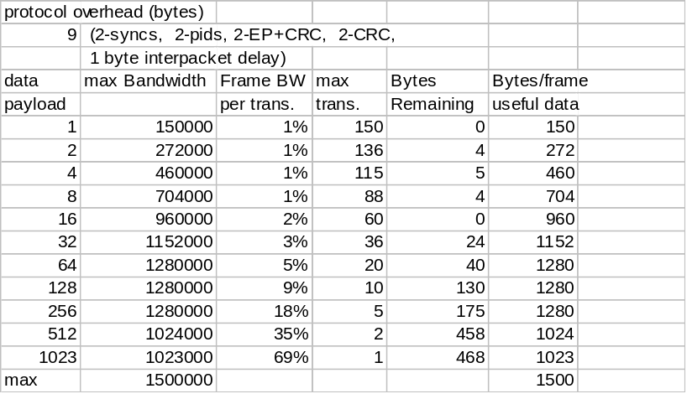
Any given transaction for a isochronous pipe need not be exactly the maximum size specified for the endpoint. The size of a data payload is determined by the transmitter (client software or function) and can vary as required from transaction to transaction. An endpoint can use the optional USB standard sample header to indicate where in the sample stream this packet starts. This allows the receiver to recover from packets lost due to errors. USB ensures that whatever size is presented to the host controller is delivered on the bus. The actual size of a data payload is determined by the data transmitter and may be less than the prenegotiated maximum size. Bus errors can change the actual size seen by the receiver. However, these errors can be detected by either CRC on the data or knowledge the receiver has about the expected size for any transaction.

Bus Access Constraints
Isochronous transfers can only be used by full speed devices.
USB requires that no more than 90% of any frame be allocated for periodic (isochronous and interrupt) transfers.
An endpoint for an isochronous pipe does not include information about bus access frequency. All isochronous pipes normally move exactly one data packet each frame (i.e., every 1 ms). Errors on the bus or delays in operating system scheduling of client software can result in no packet being transferred for a frame. An error indication is returned as status to the client software in such a case. A device can also detect this situation by tracking SOF tokens and noticing two SOF tokens without an intervening data packet for an isochronous endpoint.
The bus frequency and frame timing limit the maximum number of successful isochronous transactions within a frame for any USB system to less than 151 full speed 1 byte data payloads. Finally, a host controller, for various implementation reasons, may not be able to provide the theoretical maximum number of isochronous transactions per frame.

Data Sequences
Isochronous transfers do not support data retransmission in response to errors on the bus. A receiver can determine that a transmission error occurred. The low level USB protocol does not allow handshakes to be returned to the transmitter of an isochronous pipe. Normally handshakes would be returned to tell the transmitter whether a packet was successfully received or not. For isochronous transfers, timeliness is more important than correctness/retransmission, and given the low error rates expected on the bus, the protocol is optimized assuming transfers normally succeed. Isochronous receivers can determine whether they missed data during a frame. Also, a receiver can determine how much data was lost. Section 5.10 describes these USB mechanisms in more detail.
An endpoint for isochronous transfers never stalls since there is no handshake to report a STALL condition. The host and client software can never encounter this case. Errors are reported as status associated with the IRP for an isochronous transfer, but the isochronous pipe is not stalled in an error case. If an error is detected, the host continues to process the data associated with the next frame of the transfer. Limited error detection is possible since the protocol for isochronous transactions does not allow per transaction handshakes.

Interrupt Transfers
The interrupt transfer type is designed to support those devices that need to communicate small amounts of data infrequently, but with bounded service periods. Requesting a pipe with an interrupt transfer type provides the requester with the following:
- Guaranteed maximum service period for the pipe
- Retry of transfer attempts at the next period, in the case of occasional delivery failure due to error on the bus

Data Format
USB imposes no data content structure on communication flows for interrupt pipes.

Direction
An interrupt pipe is a stream pipe and is therefore always unidirectional. Further, an interrupt pipe is only input to the host. Output interrupt pipes are not supported by USB.

Packet Size Constraints
An endpoint for an interrupt pipe specifies the maximum size data payload that it will transmit. The maximum allowable interrupt data payload size is 64 bytes or less for full speed. Low speed devices are limited to 8 bytes or less maximum data payload size. This maximum applies to the data payloads of the data packets; i.e., the size specified is for the data field of the packet as defined in Chapter 8, not including other protocol required information. USB does not require that data packets be exactly the maximum size; i.e., if a data packet is less than the maximum, it does not need to be padded to the maximum size.
All host controllers are required to have support for up to 64 byte maximum data payload sizes for full speed interrupt endpoints and 8 bytes or less maximum data payload sizes for low speed interrupt endpoints. No host controller is required to support larger maximum data payload sizes.
USB system software determines the maximum data payload size that will be used for a interrupt pipe during device configuration. This size remains constant for the lifetime of a device’s configuration. USB software uses the maximum data payload size determined during configuration to ensure that there is sufficient bus time to accommodate this maximum data payload in its assigned period. If there is sufficient bus time, the pipe is established; if not, the pipe is not established. USB software does not adjust the bus time made available to an interrupt pipe as was the case for a control pipe. An interrupt pipe can simply either be supported or not in a given USB subsystem configuration. However, the actual size of a data payload is still determined by the data transmitter and may be less than the maximum size.
An endpoint must always transmit data payloads with a data field less than or equal to the endpoint’s MaxPacketSize. A device can move data via an interrupt pipe that is larger than MaxPacketSize. A software client can accept this data via an IRP for the interrupt transfer that requires multiple bus transactions without requiring an IRP complete notification per transaction. This can be achieved by specifying a buffer that can hold the desired data size. The size of the buffer is a multiple of MaxPacketSize with some remainder. The endpoint must transfer each transaction except the last as MaxPacketSize and the last transaction is the remainder. The multiple data transactions are moved over the bus at the period established for the pipe.
When an interrupt transfer involves more data than can fit in one data payload of the currently established maximum size, all data payloads are required to be maximum sized except for the last data payload which will contain the remaining data. If an endpoint wants to transmit less data than expected by the client software, a premature, less than maximum sized data payload will be received by the host controller. This premature, less than maximum sized data payload causes the host controller to retire the current IRP and advance to the next IRP or else stall the pipe as outlined in Section 5.3.2. If a data payload is received that is larger than that expected, the interrupt IRP will be aborted/retired and the pipe will stall future IRPs until the condition is corrected and acknowledged.

Bus Access Constraints
Interrupt transfers can be used by full speed and low speed devices.
USB requires that no more than 90% of any frame be allocated for periodic (isochronous and interrupt) transfers.
The bus frequency and frame timing limit the maximum number of successful interrupt transactions within a frame for any USB system to less than 108 full speed 1 byte data payloads or 14 low speed 1 byte data payloads. Finally, a host controller, for various implementation reasons, may not be able to provide the above maximum number of interrupt transactions per frame.
Table 5-4 lists information about different sized full speed interrupt transactions and the maximum number of transactions possible in a frame. Table 5-5 lists similar information for low speed interrupt transactions.
Table 5-4. Full Speed Interrupt Transaction Limits
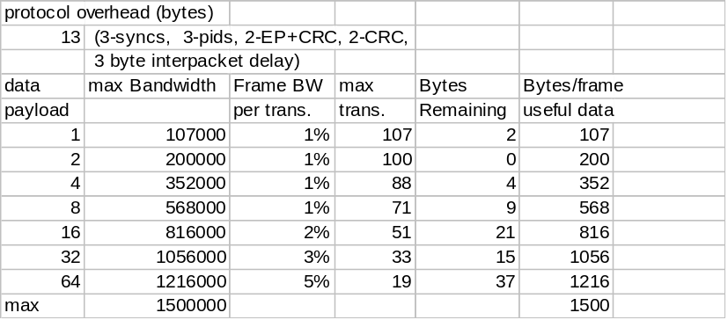
An endpoint for an interrupt pipe specifies its desired bus access period. A full speed endpoint can specify a desired period from 1 ms to 255 ms. Low speed endpoints are limited to only specifying 10 ms to 255 ms. USB software will use this information during configuration to determine a period that can be sustained. The period provided by the system may be shorter than that desired by the device up to the shortest period defined by USB. The client software and device can only depend on the fact that the host will ensure that the time duration between two error free transactions (or two transaction attempts) with the endpoint will be no longer than the desired period. Note that errors on the bus can prevent an interrupt transaction from being successfully delivered over the bus and consequently exceed the desired period. The period between any two transaction attempts can also vary over time; although it will never exceed the desired period in error free cases. Also, the endpoint is only polled when the software client has an IRP for an interrupt transfer pending. If the bus time for performing an interrupt transfer arrives and there is no IRP pending, the endpoint will not be given an opportunity to transfer data at that time. Once an IRP is requested, its data will be transferred at the next allocated period.
Table 5-5. Low Speed Interrupt Transaction Limits
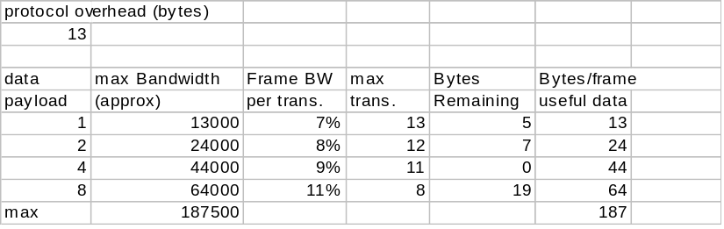
Interrupt transfers are moved over the USB by accessing an interrupt endpoint every period. The host has no way to determine whether an endpoint will source an interrupt without accessing the endpoint and requesting an interrupt transfer. If the endpoint has no interrupt data to transmit when accessed by the host, it responds with a NAK. An endpoint should only provide interrupt data when it has an interrupt pending to avoid having a software client erroneously notified of IRP complete. A zero length data payload is a valid transfer and may be useful for some implementations.

Data Sequences
Interrupt transactions may use either alternating data toggle bits such that the bits are toggled only upon successful transfer completion or a continuously toggling of data toggle bits. The host in any case must assume that the device is obeying full handshake/retry rules as defined in Chapter 8. A device may choose to always toggle DATA0/DATA1 PIDs so that it can ignore handshakes from the host. However, in this case, the client software can miss some data packets when an error occurs because the host controller interprets the next packet as a retry of a missed packet.
If a stall condition is detected on an interrupt pipe due to transmission errors or a STALL handshake being returned from the endpoint, all pending IRPs are retired. Removal of the STALL condition is achieved via software intervention through a separate control pipe. This recovery must also reset the data toggle bit to DATA0 for the endpoint. The software client must also call a USBD Function to reset the host’s data toggle to DATA0, acknowledge, and clear the stall condition on the host.
Interrupt transactions are retried due to errors detected on the bus that affect a given transfer.

Bulk Transfers
The bulk transfer type is designed to support devices that need to communicate relatively large amounts of data at highly variable times where the transfer can be deferred until bandwidth is available. Requesting a pipe with a bulk transfer type provides the requester with the following:
- Access to the USB on a bandwidth available basis
- Retry of transfers, in the case of occasional delivery failure due to error on the bus
- Guaranteed delivery of data, but no guarantees of bandwidth or latency
Bulk transfers occur only on a bandwidth available basis. For a USB with large amounts of free bandwidth, bulk transfers may happen relatively quickly; while for a USB with little bandwidth available, bulk transfers may trickle out over a relatively long period of time.

Data Format
USB imposes no data content structure on communication flows for bulk pipes.

Direction
A bulk pipe is a stream pipe and, therefore, always has communication flowing either into or out of the host for a given pipe. If a device requires bi-directional bulk communication flow, two bulk pipes must be used, one in each direction.

Packet Size Constraints
An endpoint for bulk transfers specifies the maximum data payload size that the endpoint can accept from or transmit to the bus. USB defines the allowable maximum bulk data payload sizes to be only 8, 16, 32, or 64 bytes. This maximum applies to the data payloads of the data packets; i.e.; the size specified is for the data field of the packet as defined in Chapter 8, not including other protocol required information.
A bulk endpoint is designed to support a maximum data payload size. A bulk endpoint reports in its configuration information the value for its maximum data payload size. USB does not require that data payloads be transmitted exactly the maximum size; i.e., if a data payload is less than the maximum, it does not need to be padded to the maximum size.
All host controllers are required to have support for 8, 16, 32, and 64 byte maximum packet sizes for bulk endpoints. No host controller is required to support larger or smaller maximum packet sizes.
During configuration, USB system software reads the endpoint’s maximum data payload size and ensures that no data payload will be sent to the endpoint that is larger than the supported size.
An endpoint must always transmit data payloads with a data field less than or equal to the endpoint’s reported MaxPacketSize. When a bulk IRP involves more data than can fit in one maximum sized data payload, all data payloads are required to be maximum size except for the last data payload which will contain the remaining data. If an endpoint transmits less data than expected by the client software, a premature, less than maximum sized data payload will be received by the host controller. This premature, less than maximum sized data payload causes the host controller to retire the current IRP and advance to the next IRP or else stall the pipe as was outlined in Section 5.3.2. If a data payload is received that is larger than that expected, the pipe will stall and all pending bulk IRPs for that endpoint will be aborted/retired.

Bus Access Constraints
Bulk transfers can only be used by full speed devices.
An endpoint has no way to indicate a desired bus access frequency for a bulk pipe. USB balances the bus access requirements of all bulk pipes and the specific IRPs that are pending to provide “good effort” delivery of data between client software and functions. Moving control transfers over the bus has priority over moving bulk transfers.
There is no frame time guaranteed to be available for bulk transfers as there is for control transfers. Bulk transfers are only moved over the bus on a bandwidth available basis. If there is frame time that is not being used for other purposes, bulk transfers will be moved over the bus. If there is no time in a frame available for bulk transfers, no bulk transfers will be moved in that frame. If there are too many pending bulk transfers for the available frame time, bulk transfers are selected to be moved over the bus as appropriate. If there are bulk transfers pending for multiple endpoints, bulk transfers for the different endpoints are selected according to a fair access policy that is host controller implementation dependent.
All bulk transfers pending in a system contend for the same available bus time. Because of this, the bus time made available for bulk transfers to a particular endpoint can be varied by USB system software at its discretion. An endpoint and its client software cannot assume a specific rate of service for bulk transfers. Bus time made available to a software client and its endpoint can be changed as other devices are inserted into and removed from the system or also as bulk transfers are requested for other device endpoints. Client software cannot assume ordering between bulk and control transfers; i.e., in some situations bulk transfers can be delivered ahead of control transfers.
The bus frequency and frame timing limit the maximum number of successful bulk transactions within a frame for any USB system to less than 72 8 byte data payloads. Table 5-6 lists information about different sized bulk transactions and the maximum number of transactions possible in a frame. Host controllers are free to determine how the individual bus transactions for specific bulk transfers are moved over the bus within and across frames. An endpoint could see all bus transactions for a bulk transfer within the same frame or spread across several discontiguous frames. Finally, a host controller, for various implementation reasons, may not be able to provide the above maximum number of transactions per frame.
Table 5-6. Bulk Transaction Limits
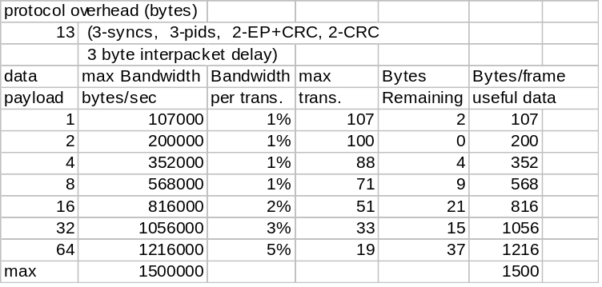

Data Sequences
Bulk transactions use data toggle bits that are toggled only upon successful transaction completion to preserve synchronization between transmitter and receiver when transactions are retried due to errors. Bulk transactions are initialized to DATA0 when the endpoint is configured by an appropriate control transfer. The host will also start the first bulk transaction with DATA0. If a bulk pipe is stalled, the data toggle on the host is reset to DATA0 when the stall is acknowledged by the software client via a USBD function. The endpoint has its stall condition cleared via an appropriate control transfer. That action also resets the endpoint’s data toggle to DATA0.
Bulk transactions are retried due to errors detected on the bus that affect a given transaction.

Bus Access for Transfers
Accomplishing any data transfer between the host and a USB device requires some use of the USB bandwidth. Supporting a wide variety of isochronous and asynchronous devices requires that each device’s transfer requirements are accommodated. The process of assigning bus bandwidth to devices is called Transfer Management. There are several entities on the host that coordinate the information flowing over USB: Client software, the USB Driver (USBD), and the Host Controller Driver (HCD). Implementers of these entities need to know the key concepts related to bus access:
- Transfer Management - The entities and the objects that support communication flow over USB.
- Transaction Tracking - The USB mechanisms that are used to track transactions as they move through the USB system.
- Bus Time - The time it takes to move a packet of information over the bus.
- Device/Software Buffer Size - The space required to support a bus transaction.
- Bus Bandwidth Reclamation - Conditions where bandwidth that was allocated to other transfers but was not used and can now be possibly reused by control and bulk transfers.
The previous sections focused on how client software relates to a function and what the logical flows are over a pipe between the two entities. This section focuses on the different parts of the host and how they must interact to support moving data over the USB. This information may also be of interest to device implementers to understand aspects of what the host is doing when a client requests a transfer and how that transfer is presented to the device.

Transfer Management
Transfer Management involves several entities that operate on different objects in order to move transactions over the bus:
- Client Software - Consumes/Generates function specific data to/from a function endpoint via calls and callbacks requesting IRPs with USBD interface.
- USB Driver (USBD) - Converts data in client IRPs to/from device endpoint via calls/callbacks with appropriate HCD. A single client IRP may involve one or more transfers.
- Host Controller Driver (HCD) - Converts IRPs to/from transactions (as required by a host controller implementation) and organizes them for manipulation by the host controller. Interactions between the host controller driver and its hardware is implementation dependent and outside the scope of the USB specification.
- Host Controller - Takes transactions and generates bus activity via packets to move function specific data across the bus for each transaction.
Figure 5-10 shows how the entities are organized as information flows between client software and the USB. The objects of primary interest to each entity are shown at the interfaces between entities.
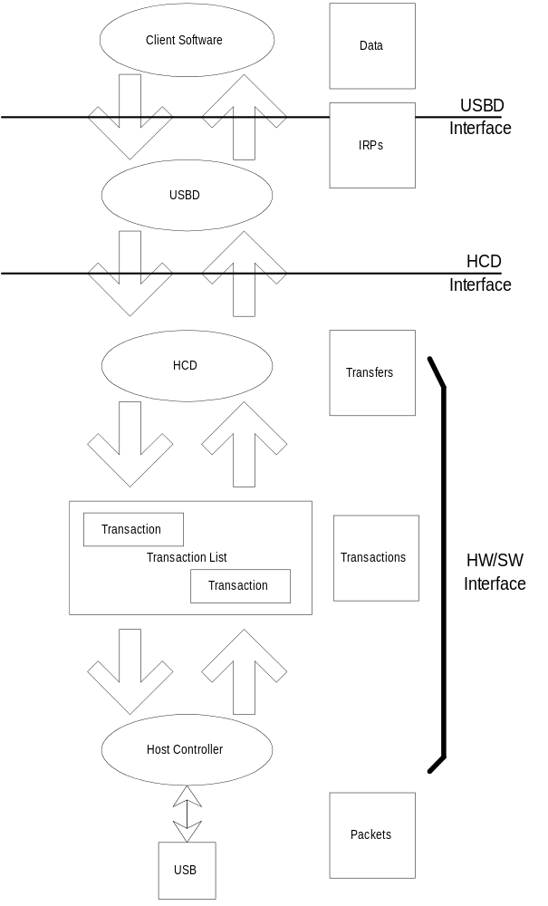
Figure 5-10. USB Information Conversion From Client Software to Bus

Client Software
Client software determines what transfers need to be made with a function. It uses appropriate operating system specific interfaces to request IRPs. Client software is only aware of the set of pipes (i.e., the interface) it needs to manipulate its function. The client is aware and adheres to all bus access and bandwidth constraints as described previously for each transfer type. The requests made by the client software are presented via the USBD interface.
Some clients may manipulate USB functions via other device class interfaces defined by the operating system and may themselves not make direct USBD calls. However, there is always some lowest level client that makes USBD calls to pass IRPs to USBD. All IRPs presented are required to adhere to the prenegotiated bandwidth constraints set when the device was attached to the bus and configured. If a function is moved from a non-USB environment to USB, the driver that would have directly manipulated the function hardware via memory or I/O accesses is the lowest client software in the USB environment that now interacts with USBD to manipulate its USB function.
After client software has requested a transfer of its function and the request has been serviced, the client software gets notified of the completion status of the IRP. If the transfer involved function to host data transfer, the client software can access the data in the data buffer associated with the completed IRP.
The USBD interface is defined in Chapter 10.

USB Driver
USBD is involved in mediating bus access at two general times while a device is attached to the bus during configuration and normal transfers. When a device is attached and configured, USBD is involved to ensure that the desired device configuration can be accommodated on the bus. The USBD receives configuration requests from the configuring software which describe the desired device configuration: endpoint(s), transfer type(s), transfer period(s), data size(s), etc. USBD either accepts or rejects a configuration request based on bandwidth availability and the ability to accommodate that request type on the bus. If it accepts the request, USBD creates a pipe for the requester of the desired type and with appropriate constraints as defined for the transfer type.
The configuration aspects of USBD are typically operating system environment specific and heavily leverage the configuration features of the operating system to avoid defining additional (redundant) interfaces.
Once a device is configured, the software client can request IRPs to move data between it and its function endpoints.

Host Controller Driver
HCD is responsible for tracking the IRPs in progress and ensuring that USB bandwidth and frame time maximums are never exceeded. When IRPs are made for a pipe, HCD adds them to the transaction list. When an IRP is complete, HCD notifies the requesting software client of the completion status for the IRP. If the IRP involved data transfer from the function to the software client, the data was placed in the client-indicated data buffer.
IRPs are defined in an operating system dependent manner.

Transaction List
The transaction list is a host controller implementation dependent description of the current outstanding set of bus transactions that need to be run on the bus. A typical transaction list consists of a series of frame descriptions in some host controller implementation dependent representation. Only HCD and its host controller have access to the specific representation. Each frame description contains transaction descriptions in which parameters such as data size in bytes, the device address and endpoint number, and the memory area to which data is to be sent or received are identified.
A transaction list and the interface between HCD and its host controller is typically represented in an implementation dependent fashion and is not defined explicitly as part of the USB specification.

Host Controller
The host controller has access to the transaction list and translates it into bus activity. In addition, the host controller provides a reporting mechanism whereby the status of a transaction (done, pending, stalled, etc.) can be obtained. The host controller converts transactions into appropriate implementation dependent activities that result in USB packets moving over the bus topology rooted in the root hub.
The host controller ensures that the bus access rules defined by the protocol are obeyed; e.g., inter-packet timings, time-outs, babble, etc. The HCD interface provides a way for the host controller to participate in whether a new pipe is allowed access to the bus. This is done because host controller implementations can have restrictions/constraints on the minimum inter-transaction times they may support for combinations of bus transactions.
The interface between the transaction list and the host controller is hidden within an HCD and host controller implementation. The host controller is typically implemented in hardware.

Transaction Tracking
A USB function sees data flowing across the bus in packets as described in Chapter 8. The host controller uses some implementation dependent representation to track what packets to transfer to/from what endpoints at what time or in what order. Most client software does not want to deal with packetized communication flows since this involves a degree of complexity and interconnect dependency that limits the implementation. USB system software (USBD and HCD) provides support for matching data movement requirements of a client to packets on the bus. The host controller hardware and software uses IRPs to track information about one or more transactions that combine to deliver a transfer of information between the client software and the function. Figure 5-11 summarizes how transactions are organized into IRPs for the four transfer types. Detailed protocol information for each transfer type can be found in Chapter 8. More information about client software views of IRPs can be found in Chapter 10 and in the operating system specific information for a particular operating system.
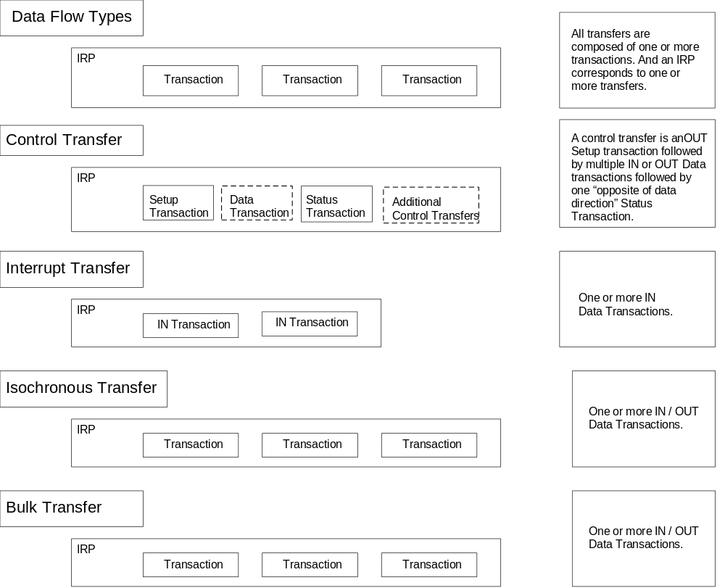
Figure 5-11. Transfers for Communication Flows
Even though IRPs track the bus transactions that need to occur to move a specific data flow over USB, host controllers are free to choose how the particular bus transactions are moved over the bus subject to the USB defined constraints; e.g., exactly one transaction per frame for isochronous transfers. In any case, an endpoint will see transactions in the order they appear within an IRP unless errors occur. For example, Figure 5-12 shows two IRPs, one each for two pipes where each IRP contains three transactions. For any transfer type, a host controller is free to move the first transaction of the first IRP followed by the first transaction of the second IRP somewhere in Frame 1, while moving the second transactions of each IRP in opposite order somewhere in Frame 2. If these are isochronous transfer types, that is the only degree of freedom a host controller has. If these are control or bulk transfers, a host controller could further move more or less transactions from either IRP within either frame. Functions cannot depend on seeing transactions within an IRP back to back within a frame.
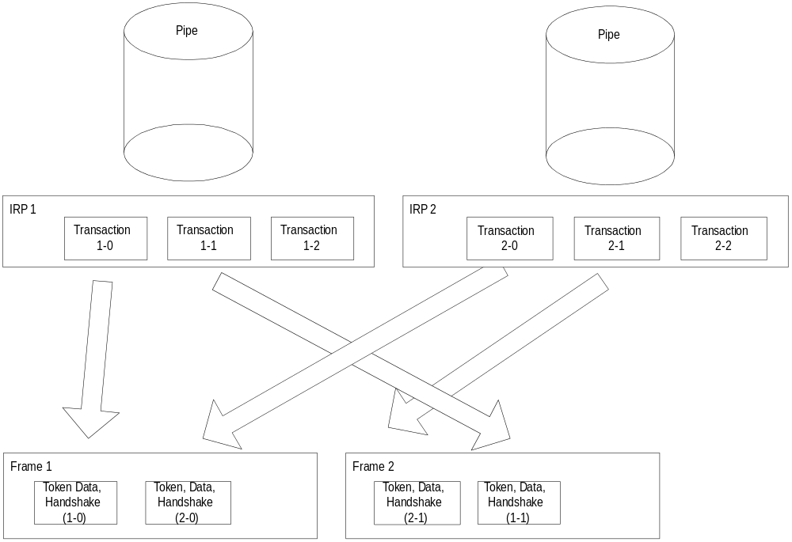
Figure 5-12. Arrangement of IRPs to Transactions/Frames

Calculating Bus Transaction Times
When the USB system software allows a new pipe to be created for the bus, it must calculate how much bus time is required for a given transaction. That bus time is based on the maximum packet size information reported for an endpoint, the protocol overhead for the specific transaction type request, the overhead due to signaling imposed bit-stuffing, inter-packet timings required by the protocol, inter-transaction timings, etc. These calculations are required to ensure that the time available in a frame is not exceeded. The equations used to determine transaction bus time are:
KEY
Data_bc Byte count of data payload
Host_Delay Time required for the host to prepare for or recover from the transmission; host controller implementation specific
Floor() Integer portion of argument
Hub_LS_Setup The time provided by the host controller for hubs to enable low speed ports; Measured as the delay from end of PRE PID to start of low speed SYNC; minimum of 4 full speed bit times.
BitStuffTime Function that calculates theoretical additional time required due to bit stuffing in signaling; worst case is (1.1667*8*Data_bc)
Full Speed (Input)
Non-Isochronous Transfer (Handshake Included)
= 9107 + (83.54 * Floor(3.167 + BitStuffTime(Data_bc))) + Host_Delay

Isochronous Transfer (No Handshake)
= 7268 + (83.54 * Floor(3.167 + BitStuffTime(Data_bc))) + Host_Delay
Full Speed (Output)
Non-Isochronous Transfer (Handshake Included)
= 9107 + (83.54 * Floor(3.167 + BitStuffTime(Data_bc))) + Host_Delay
Isochronous Transfer (No Handshake)
= 6265 + (83.54 * Floor(3.167 + BitStuffTime(Data_bc))) + Host_Delay

Low Speed (Input)
= 64060 + (2 * Hub_LS_Setup) +
(676.67 * Floor(3.167 + BitStuffTime(Data_bc))) + Host_Delay

Low Speed (Output)
= 64107 + (2 * Hub_LS_Setup) +
(667.0 * Floor(3.167 + BitStuffTime(Data_bc))) + Host_Delay

The Bus Times in the above equations are in nanoseconds and take into account propagation delays due to distance the device is from the host. These are typical equations that can be used to calculate Bus Time; however, different implementations may choose to use coarser approximations of these times.
The actual bus time taken for a given transaction will almost always be less than that calculated since bit stuffing overhead is data dependent. Worst case bit stuffing is calculated as 1.1667 times the raw time (i.e., the BitStuffTime function multiplies the Data_bc by 8*1.1667 in the equations). This means that there will almost always be time unused on the bus (subject to data pattern specifics) after all regularly scheduled transactions have completed. By placing all bulk/control transactions at the end of a frame, bit stuffing time can be calculated as less than worst case. This more aggressive calculation comes at the cost of having some bulk/control transfer’s transaction fail in a given frame every once in a while due to exceeding the frame time when enough of the previous transactions require worst case bit stuffing. The failed transaction can be retried, will seldom happen given random data patterns, and can result in a better allocation estimate for isochronous and interrupt transfer times. In any case, the bus time made available due to less bit stuffing can be reused as discussed in Section 5.9.5.
The Host_Delay term in the equations is host controller and system dependent and allows for additional time a host controller may require due to delays in gaining access to memory or other implementation dependencies. This term is incorporated into an implementation of these equations by using the Transfer Constraint Management functions provided by the HCD interface. These equations are typically implemented by a combination of USBD and HCD software working in cooperation. The results of these calculations are used to determine whether a transfer or pipe creation can be supported in a given USB configuration.

Calculating Buffer Sizes in Functions/Software
Client software and functions both need to provide buffer space for pending data transactions awaiting their turn on the bus. For non-isochronous pipes, this buffer space only needs to be large enough to hold the next data packet. If more than one transaction request is pending for a given endpoint, the buffering for each transaction must be supplied. Methods to calculate precise absolute minimum buffering a function may require because of specific interactions defined between its client software and the function are outside the scope of the USB specification.
The host controller is expected to be able to support an unlimited number of transactions pending for the bus subject to available system memory for buffer and descriptor space, etc. Host controllers are allowed to limit how many frames into the future they allow a transaction to be requested.
For isochronous pipes, Section 5.10.4 describes details affecting host side and device side buffering requirements. In general, buffers need to be provided to hold approximately twice the amount of data that can be transferred in 1 ms.

Bus Bandwidth Reclamation
USB bandwidth and bus access are granted based on a calculation of worst case bus transmission time and required latencies. However, due to the constraints placed on different transfer types and the fact that the bit stuffing bus time contribution is calculated as a constant but is data dependent, there will frequently be bus time remaining in each frame time versus what the frame transmission time was calculated to be. In order to support the most efficient use of the bus bandwidth, control and bulk transfers are candidates to be moved over the bus as bus time becomes available. Exactly how a host controller supports this is implementation dependent. A host controller can take into account the transfer types of pending IRPs and implementation specific knowledge of remaining frame time to reuse reclaimed bandwidth.

Special Considerations for Isochronous Transfers
Support for isochronous data movement between the host and a device is one of the system capabilities supported by USB. Delivering isochronous data reliably over USB requires careful attention to detail. The responsibility for reliable delivery is shared by several USB entities: the device/function, the bus, the host controller, and one or more software agents. Since time is a key part of an isochronous transfer, it is important for USB designers to understand how time is dealt within USB by these different entities.
All isochronous devices must report their capabilities in the form of device specific descriptors. The capabilities should also be provided in a form that the potential customer can use to decide whether the device offers a solution to his problem(s). The specific capabilities of a device can justify price differences.
In any communication system, the transmitter and receiver must be synchronized enough to deliver data robustly. In an asynchronous communication system, data can be delivered robustly by allowing the transmitter to detect that the receiver has not received a data item correctly and simply retrying transmission of the data.
In an isochronous communication system, the transmitter and receiver remain time and data synchronized to deliver data robustly. USB does not support transmission retry of isochronous data so that minimal bandwidth can be allocated to isochronous transfers and time synchronization is not lost due to a retry delay. However, it is critical that a USB isochronous transmitter/receiver pair still remain synchronized both in normal data transmission cases and in cases where errors occur on the bus.
In many systems that deal with isochronous data, a single global clock is used to which all entities in the system synchronize; e.g., the PSTN - Public Switched Telephone Network. Given that a broad variety of devices with different natural frequencies may be attached to USB, no single clock can provide all the features required to satisfy the synchronization requirements of all devices and software while still supporting the cost targets of mass market PC products. USB defines a clock model that allows a broad range of devices to coexist on the bus and have reasonable cost implementations.
This section presents options or features that can be used by isochronous endpoints to minimize behavior differences between a non-USB implemented function and a USB version of the function. An example is included to illustrate the similarities and differences of non-USB and USB versions of a function.
The remainder of the section presents key concepts of:
- USB Clock Model - What clocks are present in a USB subsystem that have impact on isochronous data transfers.
- USB Frame Clock to Function Clock Synchronization Options - How the USB Frame clock can relate to a function clock.
- Start of Frame Tracking - Responsibilities/Opportunities of isochronous endpoints with respect to the Start of Frame (SOF) token and USB Frames.
- Data Prebuffering - Requirements on accumulating data before generation/transmission/consumption.
- Error Handling - Isochronous specific details for error handling.
- Buffering for Rate Matching - Equations that can be used to calculate buffer space required for isochronous endpoints.

Example Non-USB Isochronous Application
The example used is a reasonably general case example. Other simpler or more complex cases are possible and the relevant USB features identified can be used or not as appropriate.
The example consists of an 8 kHz mono microphone connected through a mixer driver that sends the input data stream to 44 kHz stereo speakers. The mixer expects the data to be received and transmitted at some sample rate and encoding. A rate matcher driver on input and output converts the sample rate and encoding from the natural rate and encoding of the device to the rate and encoding expected by the mixer. Figure 5-13 illustrates this example.
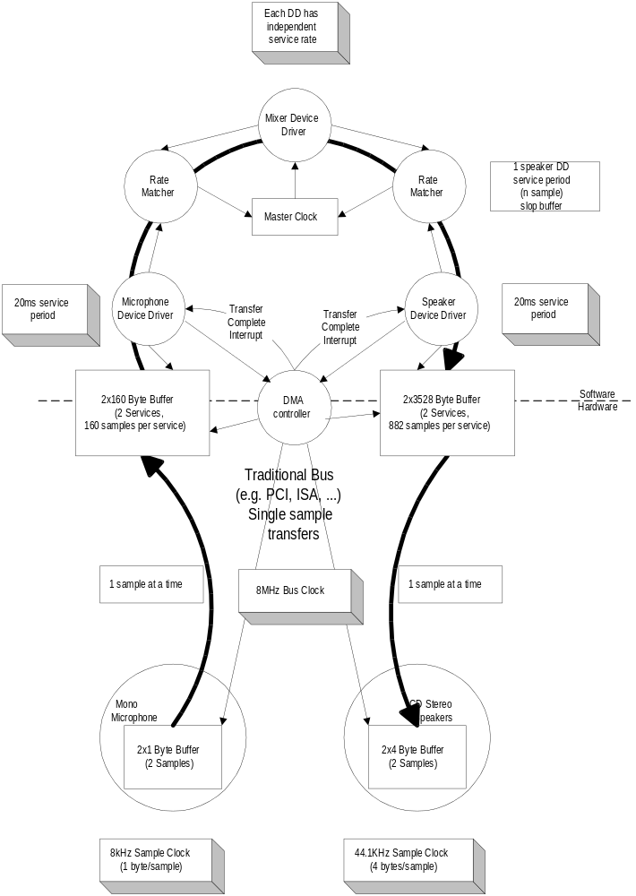
Figure 5-13. Non-USB Isochronous Example
A master clock (can be provided by software driven from the real time clock) in the PC is used to awaken the mixer to ask the input source for input data and to provide output data to the output sink. In this example, assume it awakens every 20 ms. The microphone and speakers each have their own sample clocks that are unsynchronized with respect to each other or the master mixer clock. The microphone produces data at its natural rate (1 byte samples, 8,000 times a second) and the speakers consume data at their natural rate (4 byte samples, 44,100 times a second). The three clocks in the system can drift and jitter with respect to each other. Each rate matcher may also be running at a different natural rate than either the mixer driver, the input source/driver, or output sink/driver.
The rate matchers also monitor the long term data rate of their device compared to the master mixer clock and interpolate an additional sample or merge two samples to adjust the data rate of their device to the data rate of the mixer. This adjustment may be required every couple of seconds, but typically occurs infrequently. The rate matchers provide some additional buffering to carry through a rate match.
Note that some other application might not be able to tolerate sample adjustment and would need some other means of accommodating master clock to device clock drift or else would require some means of synchronizing the clocks to ensure that no drift could occur.
The mixer always expects to receive exactly a service period of data (20 ms service period) from its input device and produce exactly a service period of data for its output device. The mixer can be delayed up to less than a service period if data or space is not available from its input/output device. The mixer assumes that such delays don’t accumulate.
The input and output devices and their drivers expect to be able to put/get data in response to a hardware interrupt from the DMA controller when their transducer has processed one service period of data. They expect to get/put exactly one service period of data. The input device produces 160 bytes (10 samples) every service period of 20 ms. The output device consumes 3528 bytes (882 samples) every 20 ms service period. The DMA controller can move a single sample between the device and the host buffer at a rate much faster than the sample rate of either device.
The input and output device drivers provide two service periods of system buffering. One buffer is always being processed by the DMA controller. The other buffer is guaranteed to be ready before the current buffer is exhausted. When the current buffer is emptied, the hardware interrupt awakens the device driver and it calls the rate matcher to give it the buffer. The device driver requests a new IRP with the buffer before the current buffer is exhausted.
The devices can provide two samples of data buffering to ensure that they always have a sample to process for the next sample period while the system is reacting to the previous/next sample.
The service periods of the drivers are chosen to survive interrupt latency variabilities that may be present in the operating system environment. Different operating system environments will require different service periods for reliable operation. The service periods are also selected to place a minimum interrupt load on the system since there may be other software in the system that requires processing time.

USB Clock Model
Time is present in the USB system via clocks. In fact, there are multiple clocks in a USB system that must be understood:
- Sample clock - This clock determines the natural data rate of samples moving between client software on the host and the function. This clock does not need to be different between non-USB and USB implementations.
- Bus clock - This clock runs at a 1.000 ms period (1 kHz frequency) and is indicated by the rate of Start of Frame(SOF) packets on the bus. This clock is somewhat equivalent to the 8 MHz clock in the non-USB example. In the USB case, the bus clock is often a lower frequency clock than the sample clock, whereas the bus clock is almost always a higher frequency clock than the sample clock in a non-USB case.
- Service clock - This clock is determined by the rate at which client software runs to service IRPs that may have accumulated between executions. This clock also can be the same in the USB and non-USB cases.
In most operating system environments that exist today, it is not possible to support a broad range of isochronous communication flows if each device driver must be interrupted for each sample for fast sample rates. Therefore, multiple samples, if not multiple packets, will be processed by client software and then given to the host controller to sequence over the bus according to the prenegotiated bus access requirements. Figure 5-14 presents an example for a reasonable USB clock environment equivalent to the non-USB example in Figure 5-13.
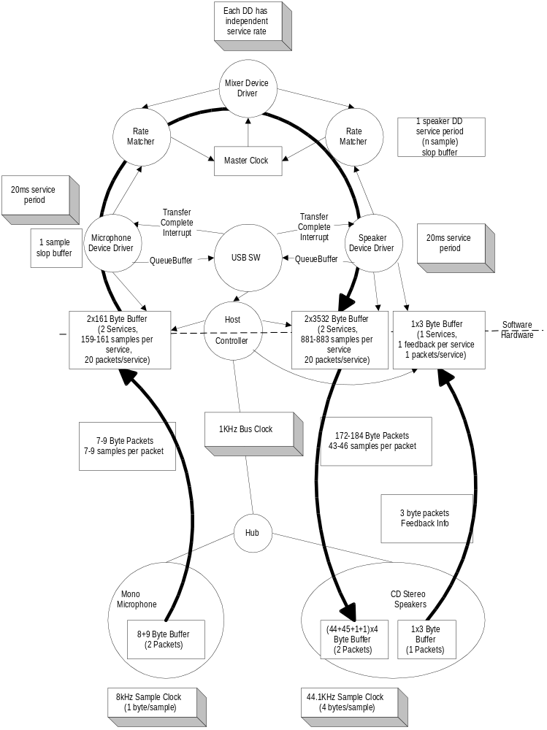
Figure 5-14. USB Isochronous Application
Figure 5-14 shows a typical round trip path of information from a microphone as an input device to a speaker as an output device. The clocks, packets, and buffering involved are also shown. Figure 5-14 will be explored in more detail in the following sections.
The focus of this example is to identify the differences introduced by USB compared to the previous non-USB example. The differences are in the areas of buffering, synchronization given the existence of a USB bus clock, and delay. The client software above the device drivers can be unaffected in most cases.

Clock Synchronization
In order for isochronous data to be manipulated reliably, the three clocks identified above must be synchronized in some fashion. If the clocks are not synchronized, several clock to clock attributes can be present that can be undesirable:
- Clock drift - Two clocks that are nominally running at the same rate can, in fact, have implementation differences that result in one clock running faster or slower than the other over long periods of time. If uncorrected, this variation of one clock compared to the other can lead to having too much or too little data when data is expected to always be present at the time required.
- Clock jitter - A clock may vary its frequency over time due to changes in temperature, etc. This may also alter when data is actually delivered compared to when it is expected to be delivered.
- Clock to clock phase differences - If two clocks are not phase locked, different amounts of data may be available at different points in time as the beat frequency of the clocks cycle out over time. This can lead to quantization/sampling related artifacts.
The bus clock provides a central clock with which USB hardware devices and software can synchronize to one degree or another. However, the software will, in general, not be able to phase or frequency lock precisely to the bus clock given the current support for “real time-like” operating system scheduling support in most PC operating systems. Software running in the host can, however, know that data moved over USB is packetized. For isochronous transfer types, a single packet of data is moved exactly once per frame and the frame clock is reasonably precise. Providing the software with this information allows it to adjust the amount of data it processes to the actual frame time that has passed.

Isochronous Devices
USB includes a framework for isochronous devices which defines Synchronization Types, how isochronous endpoints provide data rate feedback, and how they can be connected together. Isochronous devices include sampled analog devices; for example, audio and telephony devices, and synchronous data devices. Synchronization Type classifies an endpoint according to its capability to synchronize its data rate to the data rate of the endpoint that it is connected to. Feedback is provided by indicating accurately what the required data rate is, relative to the SOF frequency. The ability to make connections depends on the quality of connection that is required, the endpoint synchronization type, and the capabilities of the host application which is making the connection. Additional Device Class-specific information may be required, depending on the application.
Note that the term “data” is used very generally, and may refer to data which represents sampled analog information (like audio), or it may be more abstract information. “Data rate” refers to the rate at which analog information is sampled, or the rate at which data is clocked.
The following information is required in order to determine how to connect isochronous endpoints:
- Synchronization Type
- Asynchronous - unsynchronized, although sinks provide data rate feedback
- Synchronous - synchronized to USB’s SOF
- Adaptive - synchronized using feedback or feedforward data rate information
- Available data rates
- Available data formats
Synchronization Type and data rate information are needed to determine if an exact data rate match exists between source and sink, or if an acceptable conversion process exists which would allow the source to be connected to the sink. It is the responsibility of the application to determine whether the connection can be supported within available processing resources and other constraints (like delay). Specific USB device classes define how to describe Synchronization Type and data rate information.
Data format matching and conversion is also required for a connection, but it is not a unique requirement for isochronous connections. Details about format conversion can be found in other documents related to specific formats.

Synchronization Type
Three distinct synchronization types are defined. Table 5-7 presents an overview of endpoint synchronization characteristics for both source and sink endpoints. The types are presented in order of increasing capability.
Table 5-7. Synchronization Characteristics
 | Source | Sink
Asynchronous | Free running Fs  Provides implicit feedforward (data stream) | Free running Fs  Provides explicit feedback (interrupt pipe)
Synchronous | Fs locked to SOF  Uses implicit feedback (SOF) | Fs locked to SOF  Uses implicit feedback (SOF)
Adaptive | Fs locked to sink  Uses explicit feedback (control pipe) | Fs locked to data flow  Uses implicit feedforward (data stream)

Asynchronous
Asynchronous endpoints cannot synchronize to SOF or any other clock in the USB domain. They source or sink an isochronous data stream at either a fixed data rate (single frequency endpoints), a limited number of data rates (32 kHz, 44.1 kHz, 48 kHz, É), or a continuously programmable data rate. If the data rate is programmable, it is set during initialization of the isochronous endpoint. Asynchronous devices must report their programming capabilities in the class specific endpoint descriptor as described in their Device Class specification. The data rate is locked to a clock external to USB or to a free running internal clock. These devices place the burden of data rate matching elsewhere in the USB environment. Asynchronous source endpoints carry their data rate information implicitly in the number of samples they produce per frame. Asynchronous sink endpoints must provide explicit feedback information to an adaptive driver (refer to Section 5.10.4.2).
An example of an asynchronous source is a CD-audio player that provides its data based on an internal clock or resonator. Another example is a Digital Audio Broadcast (DAB) receiver or a Digital Satellite Receiver (DSR). Here too, the sample rate is fixed at the broadcasting side and is beyond USB control.
Asynchronous sink endpoints could be low cost speakers, running off of their internal sample clock.
Another case arises when there are two or more devices present on USB that need to have mastership control over SOF generation in order to operate as synchronous devices. This could happen if there were two telephony devices, each locked to a different external clock. One telephony device could be digitally connected to a PBX which is not synchronized to the ISDN. The other device could be connected directly to the ISDN. Each device will source or sink data to/from the network side at an externally driven rate. Since only one of the devices can take mastership over SOF, the other will sink or source data at a rate which is asynchronous to SOF. This example indicates that every device capable of SOF mastership may be forced to operate as an asynchronous device.

Synchronous
Synchronous endpoints can have their clock system (their notion of time) controlled externally through SOF synchronization. These endpoints must be doing one of the following:
- Slaving their sample clock to the 1 ms SOF tick (by means of a programmable PLL).
- Controlling the rate of USB SOF generation so that their data rate becomes automatically locked to SOF. In case these endpoints are not granted SOF mastership, they must degenerate to the asynchronous mode of operation (refer to the asynchronous example).
Synchronous endpoints may source or sink isochronous data streams at either a fixed data rate (single frequency endpoints), a limited number of data rates (32 kHz, 44.1 kHz, 48 kHz, É), or a continuously programmable data rate. If programmable, the operating data rate is set during initialization of the isochronous endpoint. The number of samples or data units generated in a series of USB frames is deterministic and periodic. Synchronous devices must report their programming capabilities in the class specific endpoint descriptor as described in their Device Class specification.
An example of a synchronous source is a digital microphone that synthesizes its sample clock from SOF and produces a fixed number of audio samples every USB frame. Another possibility is a 64 kb/s bit-stream from an ISDN “modem.” If the USB SOF generation is locked to the PSTN clock (perhaps through the same ISDN device), the data generation will also be locked to SOF and the endpoint will produce a stable 64 kb/s data stream, referenced to the SOF time notion.

Adaptive
Adaptive endpoints are the most capable endpoints possible. They are able to source or sink data at any rate within their operating range. Adaptive source endpoints produce data at a rate which is controlled by the data sink. The sink provides feedback (refer to Section 5.10.4.2) to the source which allows the source to know the desired data rate of the sink. Adaptive endpoints can communicate with all types of sink endpoints. For adaptive sink endpoints, the data rate information is embedded in the data stream. The average number of samples received during a certain averaging time determines the instantaneous data rate. If this number changes during operation, the data rate is adjusted accordingly.
The data rate operating range may center around one rate (e.g., 8 kHz), select between several programmable or auto detecting data rates (32 kHz, 44.1 kHz, 48 kHz, É), or may be within one or more ranges (e.g., 5 kHz to 12 kHz, 44 kHz to 49 kHz). Adaptive devices must report their programming capabilities in the class specific endpoint descriptor as described in their Device Class specification
An example of an adaptive source is a CD player that contains a fully adaptive sample rate converter (SRC) so that the output sample frequency no longer needs to be 44.1 kHz but can be anything within the operating range of the SRC. Adaptive sinks include such endpoints as high-end digital speakers, headsets, etc.

Feedback
An asynchronous sink provides feedback to an adaptive source by indicating accurately what its desired data rate (Ff) is, relative to the USB SOF frequency. The required data rate is accurate to better than one sample per second (1 Hz) in order to allow a high quality source rate to be created and to tolerate delays and errors in the feedback loop.
The Ff value consists of a fractional part, in order to get the required resolution with 1 kHz frames, and an integer part, which gives the minimum number of samples per frame. Ten bits are required to resolve one sample within a 1 kHz frame frequency (1000 / 2^10 = 0.98). This is a 10 bit fraction, represented in unsigned fixed binary point 0.10 format. The integer part needs 10 bits (2^10 = 1024) to encode up to 1023 1-byte samples per frame. The 10 bit integer is represented in unsigned fixed binary point 10.0 format. The combined Ff value can be coded in unsigned fixed binary point 10.10 format, which fits into three bytes (24 bits). Since the maximum integer value is fixed to 1023, the 10.10 number will be left-justified in the 24 bits, so that it has a 10.14 format. Only the first 10 bits behind the binary point are required. The lower 4 bits may be optionally used to extend the precision of Ff; otherwise, they shall be reported as 0. The bit and byte ordering follows the definitions of other multi-byte fields contained in Chapter 8.
Each frame, the adaptive source adds Ff to any remaining fractional sample count from the previous frame, sources the number of samples in the integer part of the sum, and retains the fractional sample count for the next frame. The source can look at the behavior of Ff over many frames to determine an even more accurate rate, if it needs to.
The sink can determine Ff by counting cycles of a clock with a frequency of Fs * 2^P for a period of 2^(10-P) frames, where P is an integer. P is practically bound to be in the range [0,10] because there is no point in using a clock slower than Fs, and no point in trying to update more than once a frame. The counter is read into Ff and reset every 2^(10-P) frames. As long as no clock cycles are skipped, the count will be accurate over the long term. An endpoint only needs to implement the number of counter bits that it requires for its maximum Ff.
A digital telephony endpoint, for example, will usually derive its 8 kHz Fs by dividing down the 64 kHz clock (P=3) which it uses to serialize the data stream. The 64 kHz clock phase can also give an additional 1 bit of accuracy, effectively giving P=4. This would give Ff updates every 2^(10-4) = 64 frames. A 13-bit counter would be required to obtain Ff, with 3 bits for 8 samples per frame, and 10 bits for the fractional part. The 13 bits would provide a 3.10 field within the 10.14 Ff value, with the remaining bits set to 0.
The choice of P is endpoint specific, and should be between 1 and 9, inclusive. Larger values of P are preferred, since they reduce the size of the frame counter and increase the rate at which Ff is updated. More frequent updates result in a tighter control of the source data rate, which reduces the buffer space required to handle Ff changes. P should be less than 10 so that Ff is averaged across at least two frames in order to reduce SOF jitter effects. P should not be 0 in order to keep the deviation in the number of samples sourced to less than 1 in the event of a lost Ff value.
Interrupt transfers are used to read Ff from the feedback register at periodic intervals. The desired reporting rate for the feedback should be 2^(10-P) ms (frames). Ff will be reported at most once per update period. There is nothing to be gained by reporting the same Ff value more than once per update period. The endpoint may choose to only report Ff if the updated value has changed from the previous Ff value.
It is possible that the source will deliver one too many or one too few samples over a long period, due to errors or accumulated inaccuracies in measuring Ff. The sink must have sufficient buffer capability to accommodate this. When the sink recognizes this condition, it should adjust the reported Ff value to correct it. This may also be necessary to compensate for relative clock drifts. The implementation of this correction process is endpoint specific and is not specified.
An adaptive source may obtain the sink data rate information from an adaptive sink which is locked to the same clock as the sink, as would be the case for a two-way speech connection. In this case, the feedback pipe is not needed.

Connectivity
In order to fully describe the source-to-sink connectivity process, an interconnect model is presented. The model indicates the different components involved and how they interact to establish the connection.
The model provides for multi-source/multi-sink situations. Figure 5-15 illustrates a typical situation (highly condensed and incomplete). A physical device is connected to the host application software through different hardware and software layers as described in the USB specification. At the client interface level, a “virtualized” device is presented to the application. From the application standpoint, only virtual devices exist. It is up to the device driver and client software to decide what the exact relation is between physical and virtual device.
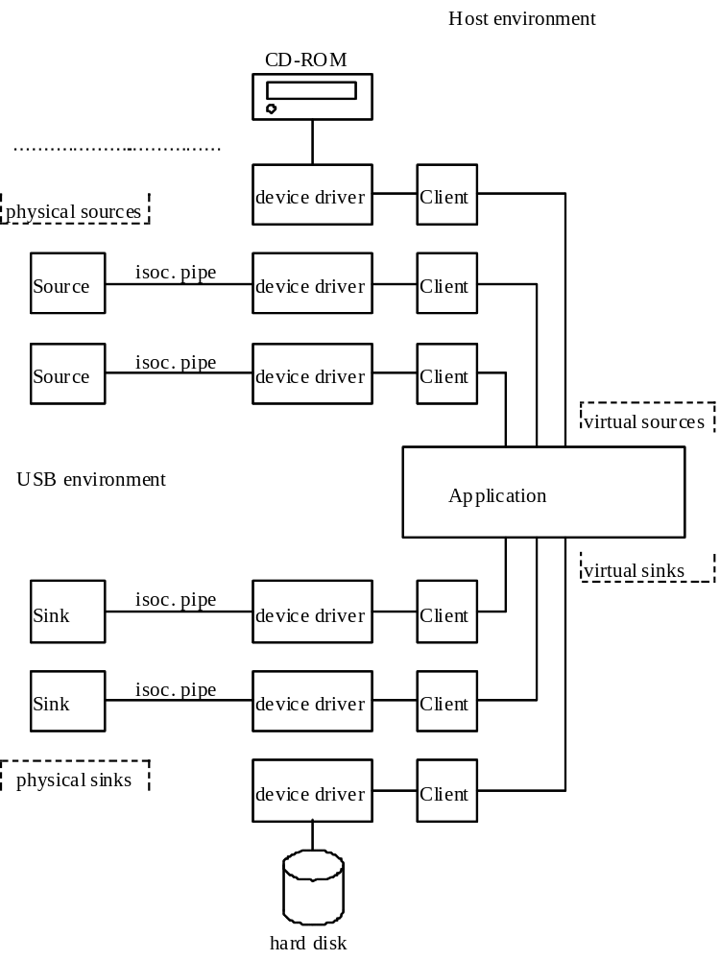
Figure 5-15. Example Source/Sink Connectivity
Device manufacturers (or operating system vendors) must provide the necessary device driver software and client interface software to convert their device from the physical implementation to a USB compliant software implementation, the virtual device. As stated before, depending on the capabilities built into this software, the virtual device can exhibit different synchronization behavior from the physical device. However, the synchronization classification equally applies to both physical and virtual devices. All physical devices belong to one of the three possible synchronization types. Therefore, the capabilities that have to be built into the device driver and/or client software are the same as the capabilities of a physical device. The word “application” must be replaced by “device driver/client software.” In the case of a physical source to virtual source connection, “virtual source device” must be replaced by “physical source device” and “virtual sink device” must be replaced by “virtual source device.” In the case of a virtual sink to physical sink connection, “virtual source device” must be replaced by “virtual sink device” and “virtual sink device” must be replaced by “physical sink device.”
Placing the rate adaptation functionality into the device driver/client software layer has the distinct advantage of isolating all applications, using the device from the specifics and problems associated with rate adaptation. Applications that would otherwise be multi-rate degenerate to simpler mono-rate systems.
Note that the model is not limited to only USB devices. A CD-ROM drive, for example, containing 44.1 kHz audio can appear as either an asynchronous, synchronous, or adaptive source. Asynchronous operation means that the CD-ROM fills its buffer at the rate that it reads data from the disk, and the driver empties the buffer according to its USB service interval. Synchronous operation means that the driver uses the USB service interval (e.g., 10 ms) and nominal sample rate of the data (44.1 kHz) to determine to put out 441 samples every USB service interval. Adaptive operation would build in a sample rate converter to match the CD-ROM output rate to different sink sampling rates.
Using this reference model, it is possible to define what operations are necessary to establish connections between various sources and sinks. Furthermore, the model indicates at what level these operations must or can take place. First there is the stage where physical devices are mapped onto virtual devices and vice versa. This is accomplished by the driver and/or client software. Depending on the capabilities included in this software, a physical device can be transformed into a virtual device of an entirely different synchronization type. The second stage is the application that uses the virtual devices. Placing rate matching capabilities at the driver/client level of the software stack relieves applications communicating with virtual devices from the burden of performing rate matching for every device that is attached to them. Once the virtual device characteristics are decided, the actual device characteristics are not any more interesting than the actual physical device characteristics of another driver.
As an example, consider a mixer application that connects at the source side to different sources, each running at their own frequencies and clocks. Before mixing can take place, all streams must be converted to a common frequency and locked to a common clock reference. This action can be performed in the physical to virtual mapping layer or it can be handled by the application itself for each source device independently. Similar actions must be performed at the sink side. If the application sends the mixed data stream out to different sink devices, it can either do the rate matching for each device itself or it can rely on the driver/client software to do that if possible.
Table 5-8 indicates at the intersections what actions the application must perform to connect a source endpoint to a sink endpoint.
Table 5-8 Connection Requirements
 | Source Endpoint
Sink Endpoint | Asynchronous | Synchronous | Adaptive
Asynchronous | Async Source/Sink RA  See Note 1. | Async SOF/Sink RA  See Note 2. | Data + Feedback Feedthrough  See Note 3.
Synchronous | Async Source/SOF RA  See Note 4. | Sync RA  See Note 5. | Data Feedthrough + Application Feedback  See Note 6.
Adaptive | Data Feedthrough  See Note 7. | Data Feedthrough  See Note 8. | Data Feedthrough  See Note 9.
Notes:
- Asynchronous RA in the application. Fsi is determined by the source, using the feedforward information embedded in the data stream. Fso is determined by the sink, based on feedback information from the sink. If nominally Fsi = Fso, the process degenerates to a feedthrough connection if slips/stuffs due to lack of synchronization are tolerable. Such slips/stuffs will cause audible degradation in audio applications.
- Asynchronous RA in the application. Fsi is determined by the source but locked to SOF. Fso is determined by the sink, based on feedback information from the sink. If nominally Fsi = Fso, the process degenerates to a feedthrough connection if slips/stuffs due to lack of synchronization are tolerable. Such slips/stuffs will cause audible degradation in audio applications.
- If Fso falls within the locking range of the adaptive source, a feedthrough connection can be established. Fsi = Fso, and both are determined by the asynchronous sink, based on feedback information from the sink. If Fso falls outside the locking range of the adaptive source, the adaptive source is switched to synchronous mode and Note 2 applies.
- Asynchronous RA in the application. Fsi is determined by the source. Fso is determined by the sink and locked to SOF. If nominally Fsi = Fso, the process degenerates to a feedthrough connection if slips/stuffs due to lack of synchronization are tolerable. Such slips/stuffs will cause audible degradation in audio applications.
- Synchronous RA in the application. Fsi is determined by the source and locked to SOF. Fso is determined by the sink and locked to SOF. If Fsi = Fso, the process degenerates to a loss-free feedthrough connection.
- The application will provide feedback to synchronize the source to SOF. Then the adaptive source appears to be a synchronous endpoint and Note 5 applies.
- If Fsi falls within the locking range of the adaptive sink, a feedthrough connection can be established.
Fsi = Fso and are determined by and locked to the source.
If Fsi falls outside the locking range of the adaptive sink, synchronous RA is done in the host to provide an Fso that is within the locking range of the adaptive sink.
- If Fsi falls within the locking range of the adaptive sink, a feedthrough connection can be established.
Fso = Fsi and are determined by the source and locked to SOF.
If Fsi falls outside the locking range of the adaptive sink, synchronous RA is done in the host to provide an Fso that is within the locking range of the adaptive sink.
- The application will use feedback control to set Fso of the adaptive source when the connection is set up. The adaptive source operates as an asynchronous source in the absence of ongoing feedback information and Note 7 applies.
In cases where RA is needed but not available, the rate adaptation process could be mimicked by sample dropping/stuffing. The connection could then still be made, possibly with a warning about poor quality; otherwise, the connection cannot be made.

Audio Connectivity
When the above is applied to audio data streams, the rate adaptation process is replaced by sample rate conversion, which is a specialized form of rate adaptation. Instead of error control, some form of sample interpolation is used to match incoming and outgoing sample rates. Depending on the interpolation techniques used, the audio quality (distortion, signal to noise ratio, etc.) of the conversion can vary significantly. In general, higher quality requires more processing power.

Synchronous Data Connectivity
For the synchronous data case, rate adaptation is used. Occasional slips/stuffs may be acceptable to many applications which implement some form of error control. Error control includes error detection and discard, error detection and retransmit, or forward error correction. The rate of slips/stuffs will depend on the clock mismatch between the source and sink, and may be the dominant error source of the channel. If the error control is sufficient, then the connection can still be made.

Data Prebuffering
USB requires that devices prebuffer data before processing/transmission to allow the host more flexibility in managing when each pipe’s transaction is moved over the bus from frame to frame.
For transfers from function to host, the endpoint must accumulate samples during frame X until it receives the Start of Frame (SOF) token packet for frame X+1. It “latches” the data from frame X into its packet buffer and is now ready to send the packet containing those samples during frame X+1. When it will send that data during the frame is determined solely by the host controller and can vary from frame to frame.
For transfers from host to function, the endpoint will accept a packet from the host sometime during frame Y. When it receives the SOF for frame Y+1, it can then start processing the data received in frame Y.
This approach allows an endpoint to use the SOF token as a stable clock with very little jitter/drift when the host controller moves the packet over the bus while also allowing the host controller to vary within a frame precisely when the packet is actually moved over the bus. This prebuffering introduces some additional delay between when a sample is available at an endpoint and when it moves over the bus compared to an environment where the bus access is at exactly the same time offset from SOF from frame to frame.
Figure 5-16 shows the time sequence where for a function to host transfer (IN process), data D₀ is accumulated during frame F_{i} at time T_{i}, and transmitted to the host during frame F_{I+1}. Similarly, for a host to function transfer (OUT process), data D₀ is received by the endpoint during frame F_{i+1} and processed during frame F_{i+2}.
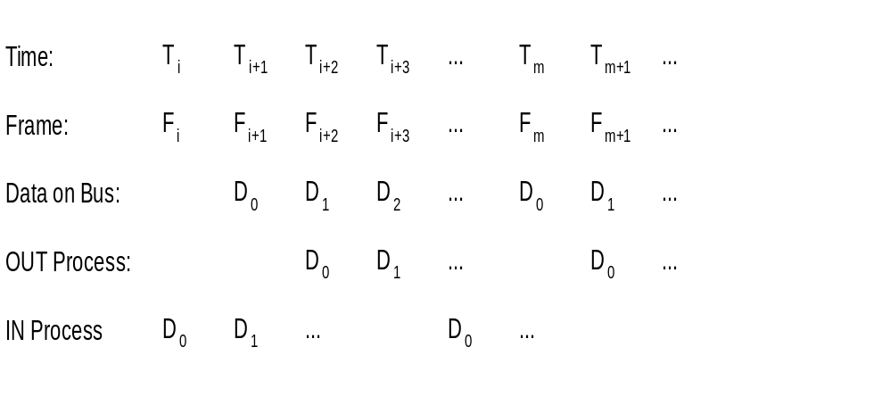
Figure 5-16. Data Prebuffering

SOF Tracking
Functions supporting isochronous pipes must receive and comprehend the SOF token to support prebuffering as previously described. Given that SOFs can be corrupted, a device must be prepared to recover from a corrupted SOF. These requirements limit isochronous transfers to full speed devices only, since low speed devices do not see SOFs on the bus. Also, since SOF packets can be damaged in transmission, devices that support isochronous transfers need to be able to synthesize the existence of an SOF that they may not see due to a bus error.
Isochronous transfers require the appropriate data to be transmitted in the corresponding frame. USB requires that when an isochronous transfer is presented to the host controller, it identifies the frame number for the first frame. The host controller must not transmit the first transaction before the indicated frame number. Each subsequent transaction in the IRP must be transmitted in succeeding frames. If there are no transactions pending for the current frame, then the host controller must not transmit anything for an isochronous pipe. If the indicated frame number is passed, the host controller must skip (i.e., not transmit) all transactions until the one corresponding to the current frame is reached.

Error Handling
Isochronous transfers provide no data packet retries (i.e., no handshakes are returned to a transmitter by a receiver) so that timeliness of data delivery is not perturbed. However, it is still important for the agents responsible for data transport to know when an error occurs and how the error affects the communication flow. In particular, for a sequence of data packets (A,B,C,D), USB allows sufficient information such that a missing packet (A,_,C,D) can be detected and will not unknowingly be turned into an incorrect data or time sequence (A,C,D or A,_,B,C,D). The protocol provides four mechanisms that support this: exactly one packet per frame, SOF, CRC, and bus transaction timeout.
Isochronous transfers require exactly 1 data transaction every frame for normal operation. USB does not dictate what data is transmitted in each frame. The data transmitter/source determines specifically what data to provide. This regular data per frame provides a framework that is fundamental to detecting missing data errors. Any phase of a transaction can be damaged during transmission on the bus. Chapter 8 describes how each error case affects the protocol.
Since every frame is preceded by an SOF packet and a receiver can see SOFs on the bus, a receiver can determine that its expected transaction did not occur between two SOFs. Additionally, since even an SOF packet can be damaged, a device must be able to reconstruct the existence of a missed SOF as described in Section 5.10.6.
A data packet may be corrupted on the bus; therefore, CRC protection allows a receiver to determine that the data packet it received was corrupted.
Finally, the protocol defines the details that allow a receiver to determine via bus transaction timeout that it is not going to receive its data packet after it has successfully seen its token packet.
Once a receiver has determined that a data packet was not received, it may need to know the size of the data that was missed in order to recover from the error with regard to its functional behavior. If the communication flow is always the same data size per frame, then the size is always a known constant. However, in some cases the data size can vary from frame to frame. In this case, the receiver and transmitter have an implementation dependent mechanism to determine the size of the lost packet.
In summary, whether a transaction is actually moved successfully over the bus or not, the transmitter and receiver always advance their data/buffer streams one transaction per frame to keep data per time synchronization. The detailed mechanisms described above allow detection, tracking, and reporting of damaged transactions so that a function or its client software can react to the damage in a function appropriate fashion. The details of that function/application specific reaction are outside the scope of the USB specification.

Buffering for Rate Matching
Given that there are multiple clocks that affect isochronous communication flows in USB, buffering is required to rate match the communication flow across USB. There must be buffer space available both in the device per endpoint and on the host side on behalf of the client software. These buffers provide space for data to accumulate until it is time for a transfer to move over USB. Given the natural data rates of the device, the maximum size of the data packets that move over the bus can also be calculated. Figure 5-17 shows the equations used to determine buffer size on the device and host and maximum packet size that must be requested to support a desired data rate. These equations allow a device and client software design time determined service clock rate (variable X), sample clock rate (variable C), and sample size (variable S). USB only allows one transaction per bus clock. These equations should provide design information for selecting the appropriate packet size that an endpoint will report in its characteristic information and the appropriate buffer requirements for the device/endpoint and its client software. Figure 5-14 shows actual buffer, packet, and clock values for a typical isochronous example.
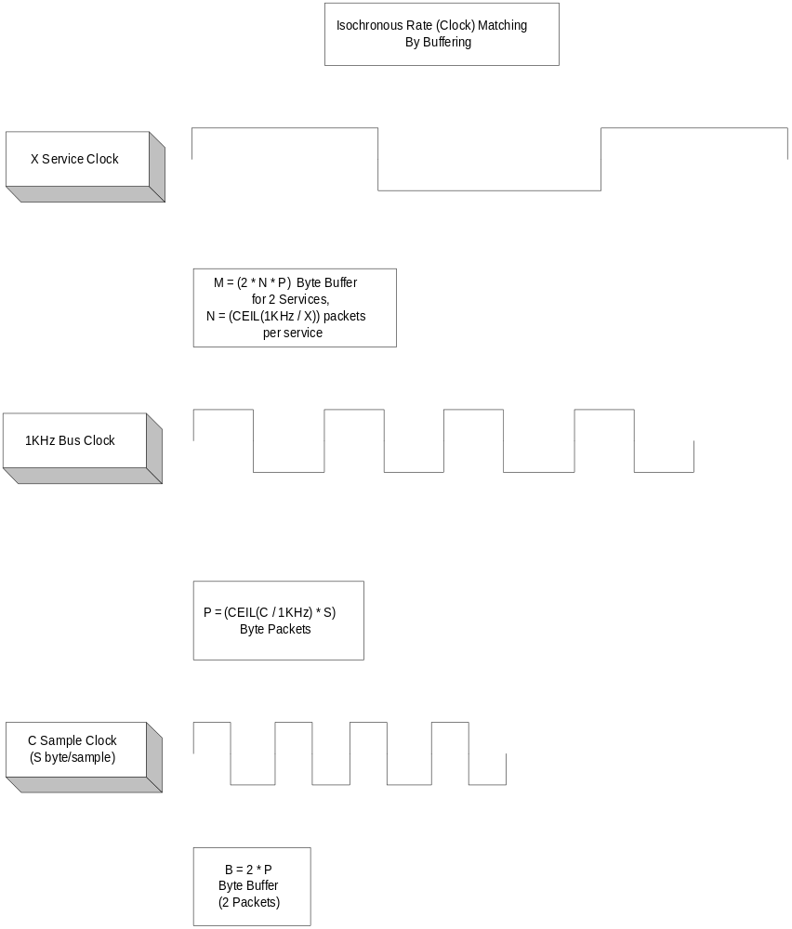
Figure 5-17. Packet and Buffer Size Formulas for Rate Matched Isochronous Transfers
The USB data model assumes that devices have some natural sample size and rate. USB supports the transmission of packets that are multiples of sample size to make error recovery handling easier when isochronous transactions are damaged on the bus. If a device has no natural sample size or if its samples are larger than a packet, it should describe its sample size as being one byte. If a sample is split across a data packet, the error recovery can be harder when an arbitrary transaction is lost. In some cases, data synchronization can be lost unless the receiver knows in what frame number each partial sample is transmitted. Furthermore, if the number of samples can vary due to clock correction (e.g., for a non-derived device clock), it may be difficult or inefficient to know when a partial sample is transmitted. Therefore, USB does not split samples across packets.

